C:\Users\Eve\AppData\Local\Microsoft\Windows\Temporary Internet Files\Content.IE5\TO6S67N8\MC900292594[1].wmf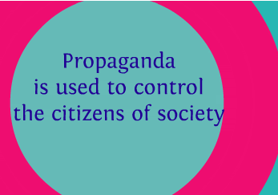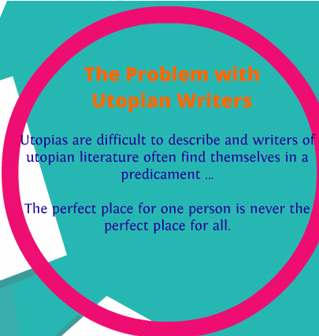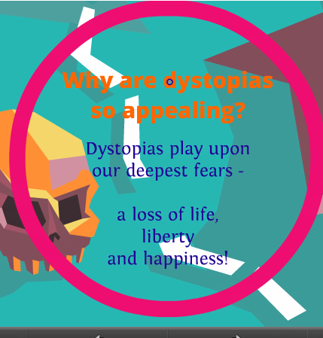

How can I express my ideas if I am being ________________

It depicts a world in which the American Dream  
has turned into a nightmare because it has been

_______________________________

It is a story about a love affair with

________and__________

**Framiliarity**

Protagonist who questions_________

Utopia

**Definition of a Dystopia**

**Characteristics**

**of a dystopian society**

Written by _________________

In 19____