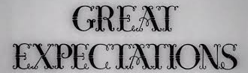
Name______________________________________________
Period __________
Active Reading
Great Expectations Chapters 1–10
The first ten chapters of the novel introduce you to a variety of characters who affect Pip’s life. As you read, think about Pip’s relationships with these people and their effect on him. Make notes in the cluster diagram below. On the lines, explain the relationship between Pip and each character. In the circles, describe how each affects Pip.
