Everyone has the right to feel safe whether it is in school or online. Unfortunately, that isn’t always the case. In this project, you will learn more about the types of bullying and then create a brochure or one-minute advertisement to help inform other students and parents about bullying and how to prevent it.
Anti-Bullying Campaign Assignment
Step 1 Friday 11/6
Research the questions about bullying by answering the questions on the worksheet. Sources: You must keep a list of what sources you use for your works cited page. When you answer a question make sure you write down all the information you will need for your works cited page. Consult your Research Guide.
Step 2 Monday (11/9) & Tuesday (11/10)
Using your research notes, plan and produce a brochure using MS Publisher or Microsoft Word
The following items are required to be in your brochure.
- A catchy slogan/title for your brochure (ex. “Bullying Stops Here”, “Help Stop bullying Before it Starts”, “Stand Up to bullying”)
- Must use “brochure format” – download a template from Microsoft Word
- Must include 3 images in your brochure
- Six sections plus
Your Brochure must include:
- You must define three out of the five types of bullying.
- What you can do if you are bullied?
- What roll should a bystander play? How can a bystander make a difference? What you can do if you see someone being bullied?
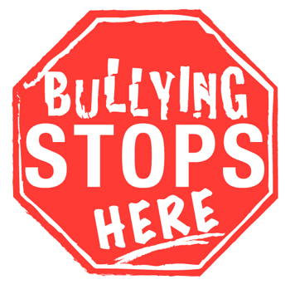
- Who can help? (Provide information where people can get help and support) Needs to be in WC
- At least three statistics from 2 different sources (ex. 50% of all teens have been bullied).
- At least 3 graphics: Make sure they are relevant and appropriate. You may use your own original graphics.
- Works Cited (Total 3 sources in MLA format)
Finally, your brochure must make sense and be helpful to students looking for information on bullying.
Research Guide
- List and describe three out of the five types of bullying.
Type | Description/Examples

- What you can do if you are bullied?

- What roll should a bystander play?

- How can a bystander make a difference?

- What you can do if you see someone being bullied?

- Who can help? (Provide information where people can get help and support)
People/places to go to for help | Source you got the information from
*One of these sources needs to be in Works Cited

- At least three statistics
Three Facts/Statistics | Source you got the information from
*Must be from 2 different sources

- List your 3 sources for your Works Cited (must be in MLA format)
Source | MLA Citation

