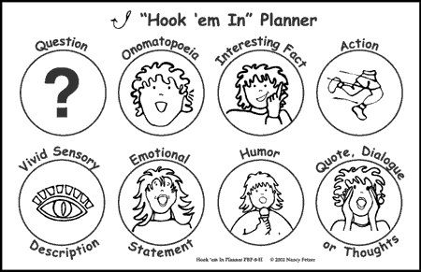
Attention Grabbers - different ways to grab the attention of a reader
- A definition:
While dictionary definitions are ok, most people find them to be quite dry. Try to paraphrase, or write your own unique take on a definition whenever you can.
“When people intentionally make false statements, they are telling a lie. Lies are regarded as sins, vices, transgressions, and immoral offences.”
“Business is more than just an exchange of funds for services or goods.”
- A quotation or paraphrase:
If you use a quote, make sure that it is relevant to your topic, background information or your thesis in some way. Avoid over-used quotes or clichés, or if you must, try to put your own original spin on an old cliché.
“The playwright George Bernard Shaw provided the memorable definition ‘Those who can, do. Those who can’t, teach.’ The film director Woody Allen took the definition one step further: ‘Those who can’t teach, teach gym’.”
- An interesting incident or anecdote related to your subject:
If you have observed or experienced something personally that can demonstrate why the topic interests you, then your reader will likely be interested as well.
“At the supermarket, a cashier, I classified their customers according to how they relate to the items they purchased.”
- Shocking Statistic:
A shocking statistic is a factual statistic that deals with your essay topic and is surprising to your reader. Often, it will be a statistic that most people do not know, and will make them think about your essay topic in a new way. Shocking statistics can be effective in persuasive essays when readers may not have thought about all aspects of one side of the argument. They can also be very effective in informative essays or essays with a lot of technical information.

- A paradox:
Paradoxes are difficult to articulate well. That being said, they are also very effective in conveying contrasting emotions, feelings, or even sides in a very short span of writing. They hold a great amount of gravity, and should be used sparingly to increase their effect.

With the explosion of the first atomic bomb came the advent of the greatest weapon of war the world has ever seen—soon, though, it was to be used to bring a new peace to a broken world.

- Historical review:
Immediately placing your paper in historical context can be very helpful and give a solid, interesting start to the piece. This technique can be applied to a huge variety of situations, ranging from specific people, to current events, to past events, to ongoing cultural change. With this, it’s best to start with a very specific example that can be applied to the topic as a whole.

“It was April, 1865, and the air was thick with joy and tension at the Appomattox Courthouse.”

