Plot Elements Part 2: Characterization http://www.youtube.com/watch?v=B_GVgbykf8A

Direct Characterization:

VS
Indirect Characterization:

Complexity | Flat | Round
Change | Static | Dynamic

Conflicts:

List 3 of the suggestions to look for that help describe a Character

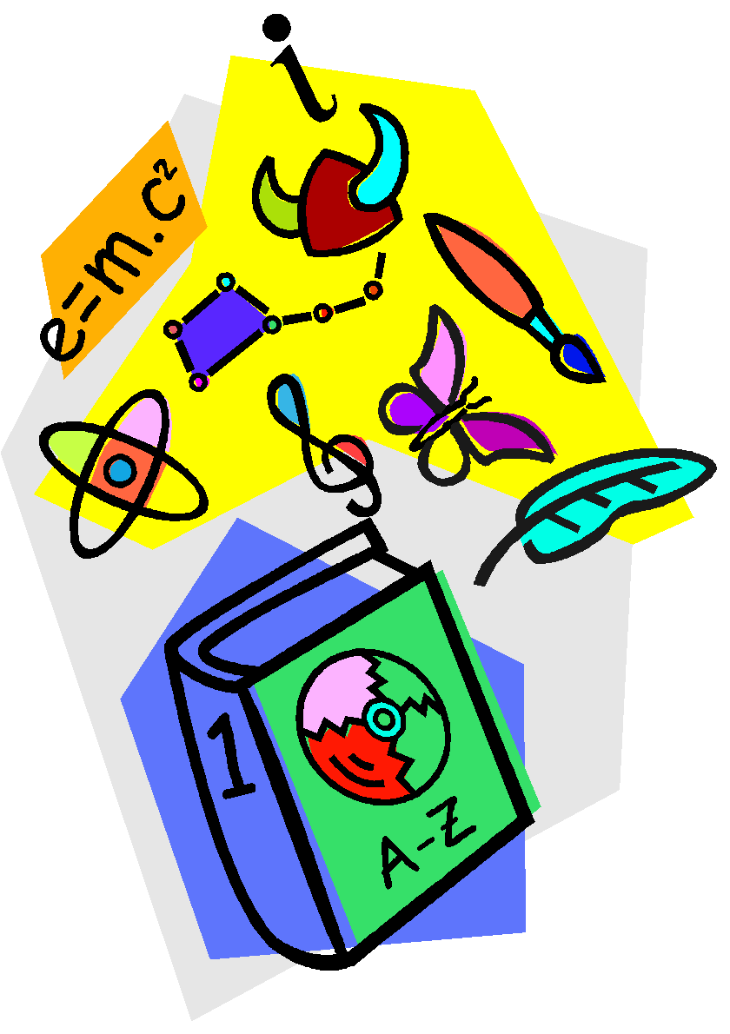

Definition of Characterization:

