Bradbury’s Fahrenheit 451: A Vision of the World Today?
Consider…
Wright argues, in his essay “The Incendiary Prophet”, that Bradbury’s 451 ” is an inspired criticism of what we now call the ‘information society’, and the yawning chasm it is creating in our collective soul. In it, he managed to predict, with frightening accuracy, such current social pathologies as: the dumbing down of popular entertainment and education, our growing addiction to empty sensory stimulation, the rise of random violence among youth, the increasing anomie and alienation among everyone, the cult of pharmacy, the cult of consumerism, the cult of the victim… the resulting right of everyone never to be offended…and our increasing [desire for] atomization” (The incendiary prophet). Bradbury wrote this novel over fifty years ago, yet captured m any attributes of our modern society with such authenticity it is hard to believe he imagined it. The parallels between the world of his story and the world we live in are hard to ignore.
Instructions…
Think about the commentary above. Ponder some of the following: Bradbury’s success in creating a realistic future world, the fears he notes that are now part of our daily existence and other key issues regarding the “information society” in which we live.

- Brainstorm some ideas/issues/themes from the novel

- Choose three of your ideas from above __________________________________________________________

- Book Time: Select the 3 quotations you think illustrates this idea best and copy it down with the page number.
- (Quote 1) First, find an example in the novel of the ideas/issues/themes

(Bradbury______ )

- (Quote 2) First, find an example in the novel of the ideas/issues/themes

(Bradbury______ )
- (Quote 3) First, find an example in the novel of the ideas/issues/themes

(Bradbury______ )

- Brainstorm again! Jot down some of the instances you can come up with that show your chosen quotation and its link to current society

- Internet Savvy: Find an online article highlighting each of your 3 issue and print them out. TOTAL OF 3 ARTICLES –ONE FOR EACH OF YOUR 3 TOPICS/IDEAS

- Article Time: Select a quote from the article that best illustrates your issue 1 (Quote 1) and copy it down with proper MLA citation.

- Article Time: Select a quote from the article that best illustrates your issue 2 (Quote 2) and copy it down with proper MLA citation.

- Article Time: Select a quote from the article that best illustrates your issue 3 (Quote 3) and copy it down with proper MLA citation.

My example…
Mildred sleeps every night with the sea shells in her ear

Book Quotation #1: “There was a tiny dance of melody in the air; her seashell was tamped in her ear again…”

(Bradbury 42).

Article Quotation #2 Earbuds are lightweight, but they shouldn’t be light on features. Many wireless in-ear headphones allow you to pair them with several devices …moisture resistant [and] noise cancelation[s] are also excellent features.

Wireless Earbuds Review Toptenreviews.com

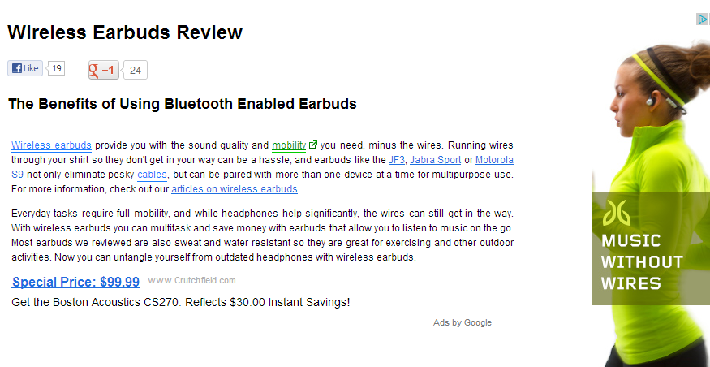

Word Wizard Time: Now, type a small summary explaining how the world of his story (include Quote #1) and the world we live in (include Quote #2) are indeed parallel. Include quote integration and parenthetical documentation, (see last page for the format). Be prepared to share and your team’s quotes and article with the class.

_________________________________________________________________
Summary:
Ray Bradbury wrote Fahrenheit 451 over fifty years ago, yet he captured many attributes of our modern society with such authenticity it is hard to believe he imagined it. The parallels between the world of his story and the world we live in are hard to ignore. Bradbury describes the character of Mildred as an image of our overly informed/distracted society. To begin, Bradbury describes, “Late at night [Montage] looks over at Mildred. She was awake. There was a tiny dance of melody in the air, her seashell was tampered in her ear again and she was listening to far people in far places…staring at the fathoms of blackness above her in the celling” (78). Mildred wears to shells to allow herself to remain numb, just as she watches the parlour constantly, takes too many pills and tunes out others around her, such as her husband Montage. In today’s society, “Many wireless in-ear headphones allow you to pair them with several devices …moisture resistant [and] noise cancelation[s] are also excellent features” (Wireless Earbuds Review). Mildred reminds me of those people who are constantly listening to iPods or to cell phones, often ignoring the polite rules of society, as a means of staying tuned all the time to their media needs much like my students in class. __________________(In the novel), ___________________________________________________________
________________________________________________________________________________________
_________________________________________________________________________________________ In today’s society), _________________________________________________________________________
_____________________________________________________________________________________________________________________________________________________________________________________________________________________________________________________________________________________________(In the novel), ___________________________________________________________
________________________________________________________________________________________
_________________________________________________________________________________________ In today’s society, __________________________________________________________________________
__________________________________________________________________________________________________________________________________________________________________________________ Concluding sentence________________________________________________________________________
_________________________________________________________________________________________
__________________________________________________________________________________________________________________________________________________________________________________
Be sure to include Quote 1 form the book
Be sure to include

Be sure to include Quote 1 form an article

Be sure to include Quote 2 form the book
Transition word

Be sure to include Quote 2 form an article

Be sure to include Quote 3 form the book
Transition word
Be sure to include Quote 3 form an article

