The Heroe’s Journey Self-Editing Check List
Make sure you put the title of the movie and the poem in italic and capitalize the T and the O in The Odyssey
in the first place
not only ... but also
as a matter of fact
in like manner
in addition
coupled with
in the same fashion / way
first, second, third
consequently
therefore
thereupon
forthwith
accordingly
henceforth
after all
in fact
in summary
in conclusion
in short
in brief
to summarize
on balance
altogether
overall
ordinarily
above all, chiefly, with attention to, especially, particularly, singularly
for example, for instance, for one thing, as an illustration, illustrated with, as an example, in this case
comparatively, coupled with, correspondingly, identically, likewise, similar, moreover, together with at first, first of all, to begin with, in the first place, at the same time, for now, for the time being, the next step, in time, in turn, later on, meanwhile, next, then, soon, the meantime, later, while, earlier, simultaneously, afterward, in conclusion, with this in mind after all, all in all, all things considered, briefly, by and large, in any case, in any event, in brief, in conclusion, on the whole, in short, in summary, in the final analysis, in the long run, on balance, to sum up, to summarize, finally also, again, as well as, besides, coupled with, furthermore, in addition, likewise, moreover, similarly

Period 4: FINAL COPY DUE ON TURNITIN.COM
On__________________________
NO LATE APAERS WILL BE ACCEPTED!!!
Transition words
- Check you essay for the words “I,” “You,” and “essay” Unless these words are in a quotation, remove them!
- Check for all contractions that aren’t are not part of a quote, and remove them! (it’s = it is didn’t = did not)
- Check for “big,” “small,” “a lot,” “good,” and “bad.” Again, if they are not part of a quote, remove them!
In all 4 paragraphs:
- Highlight the fist word of every sentence in red.
- Highlight your topic sentences and concluding sentences in yellow.
For Body 1 ONLY:
- Highlight your “set up quote” sentences in purple.
- Highlight your quote integrations in blue in body 1
- Highlight your quotes in green
- Highlight your Quote explanation sentence in deep purple
For Body 2 ONLY:
- Highlight your comparison sentence in teal in body 2
- Check to see if your punctuated each sentence with your quotes correctly.
- Check that your parenthetical documentations are correct.
Mrs. Dudek reminded us over and over “each quote needs an integration” (Dudek 111).
The period goes last
- Highlight your explanation sentence in blue.
- Underline your transition words. You should have 4 in each body paragraph and in your concluding paragraph.
Check that you do not have “This quote…” in your essay!!!
- Count your paragraphs, and be sure you have four and each is indented 5 five spaces
- Check that you spelled out the numbers in your sentences that are less than 100 one hundred.
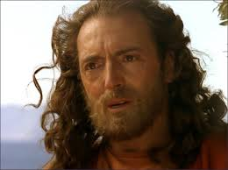
- Check your commas and punctuation. Make any corrections that may be needed.
- NTSSWTSW =No Two Sentences Start With The Same Word in the same paragraph. Since you used transition words, this should not be much of a problem.
- Presentation: Double spaces, Times New Roman 12 point font in MLA style, including 1inch margins, an essay title centered at the top, header, and a heading (aligned right) with your name, Mrs. Dudek, class title and period, then date (Day month year). 10 pts.
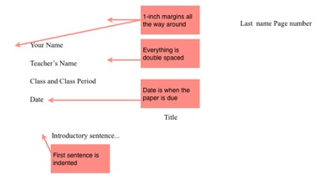
Your paper should look like this
The period goes last
Other ways to say “said”
acknowledges | comments | describes | maintains | reports
adds | compares | disputes | notes | responds
admits | concedes | emphasizes | observes | shows
agrees | confirms | endorses | points out | states
argues | contends | illustrates | reasons | suggests
asserts | declares | implies | refutes | summarizes
claims | denies | insists | rejects | writes

