https://www.youtube.com/watch?v=-catJZm_2TI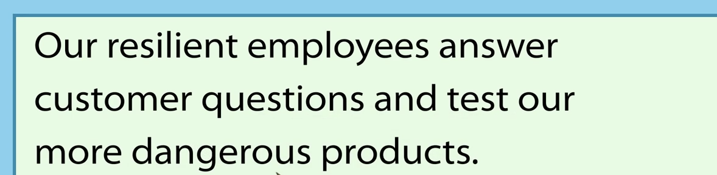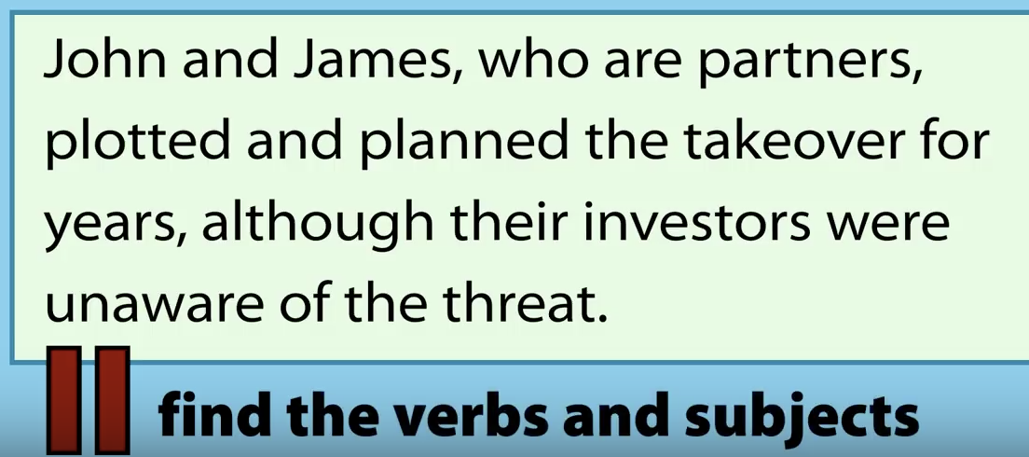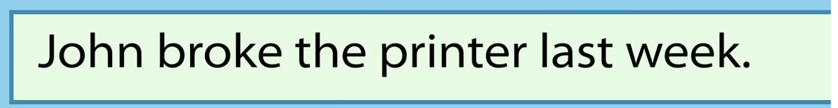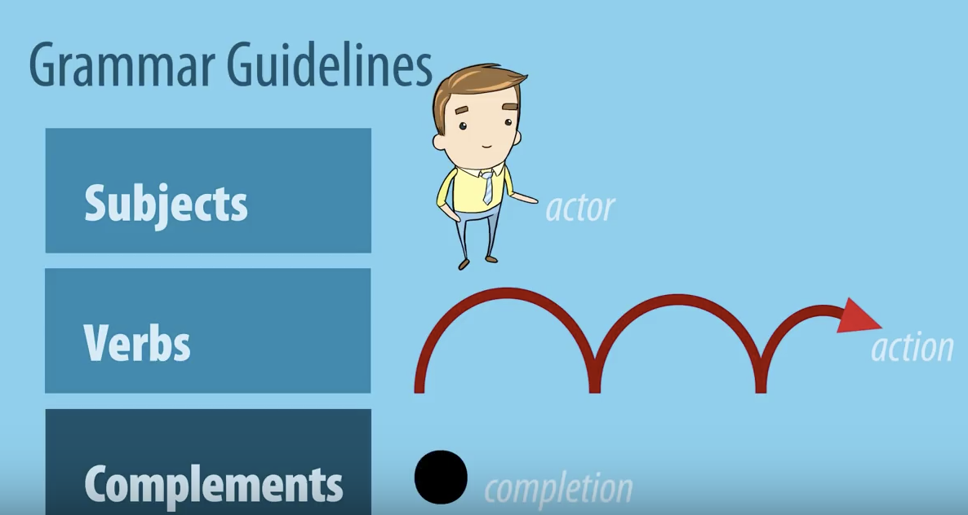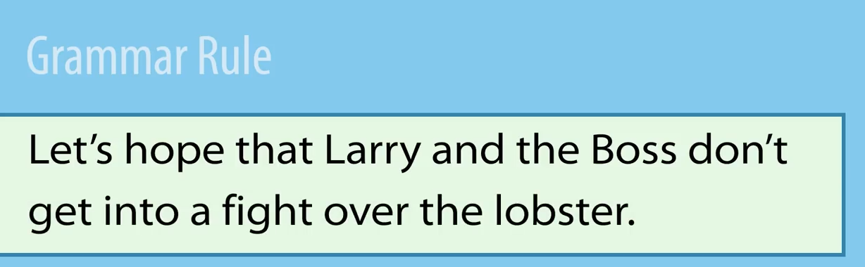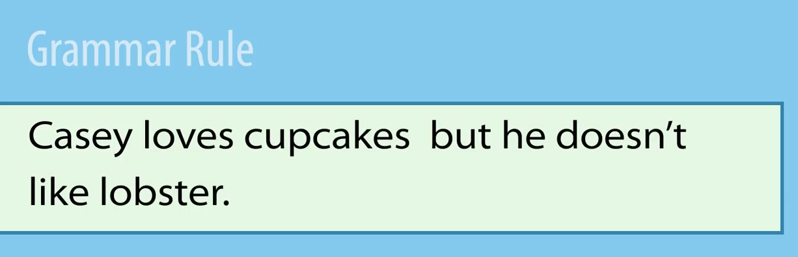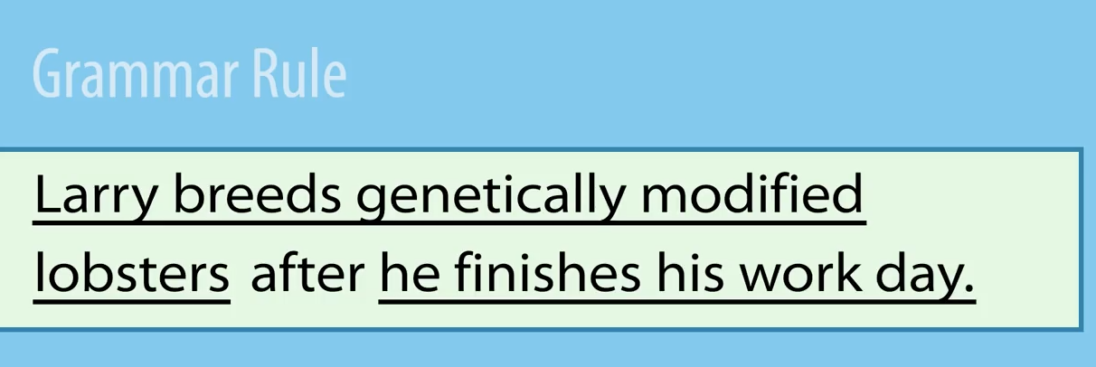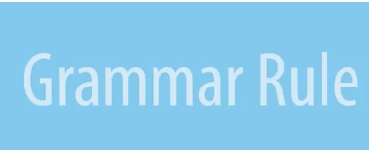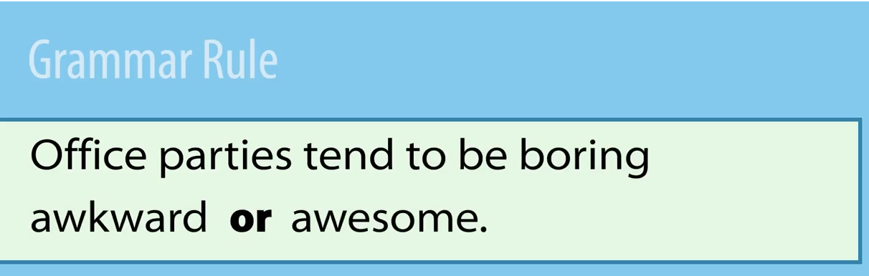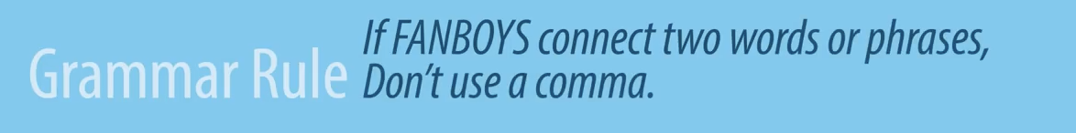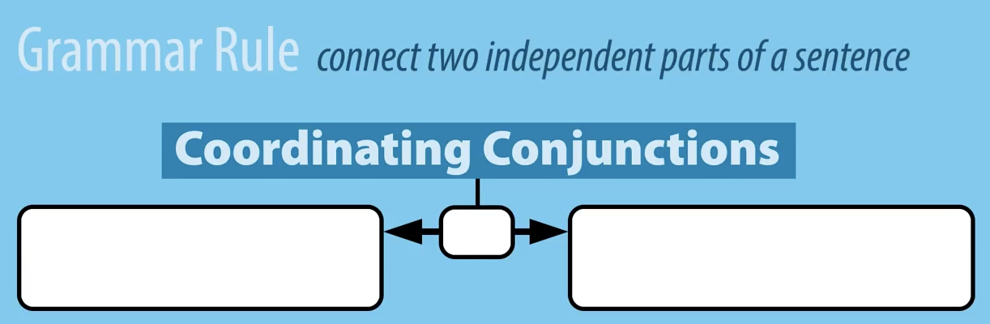

Name _________________________________________

https://www.youtube.com/watch?v=-catJZm_2TI

Sometimes the verb isn’t an action but______________________________t

Remember, if you mash two sentences together without something to join them you get ____________________

When _____________________________________

Connect clauses of _________________ strength

They need a ______________________.

Use commas between

If FANBOYS connect

Don’t use a comma if