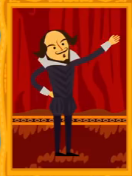
Name _____________________________ Period ______

1. What is the stress pattern of an iamb?
A Stressed, unstressed
B Unstressed, stressed
C Stressed, stressed
D Unstressed, unstressed

2. Iambic pentameter contains _____ feet, each of which contains _____ syllables.
A Two, five
B Five, five
C Five, two
D Three, two

3. Which of these is NOT a type of metrical foot?
A Ptero
B Dactyl
C Iamb
D Trochee

4. Which of these lines is NOT in iambic pentameter?
A "But soft! What light through yonder window breaks?"
B "A little more than kin and less than kind."
C "Just for a handful of silver he left us."
D "So foul and fair a day I have not seen."

5. Shakespeare's characters often speak in iambic pentameter when they are feeling _____.
A Heightened emotions
B Introspective
C Passionate
D All of the above

6.-7. Meter is all about _____________ not ________________.

8. One line of verse is usually made up of several _________________.

9. When you combine three iambs, you can create poetry in iambic trimester. Which of the following are an example of
a. The only news I know is
b. A host of golden daffodils.
c. But, soft! what light through yonder window breaks?

10. The word poetry is how many syllables.
a. 2 b. 3 c. 4

