Scoring Rubrics
Name _________________________________ Period________
Organization/Appearance /creativity Scrapbook is organized and visually appealing
- 5 points
- profile page

Must be on-time and uploaded to turnitin.com and edu2.0 class page for full credit. -10 points each day it is late for the first 3 days then lowered one letter grade each day after.
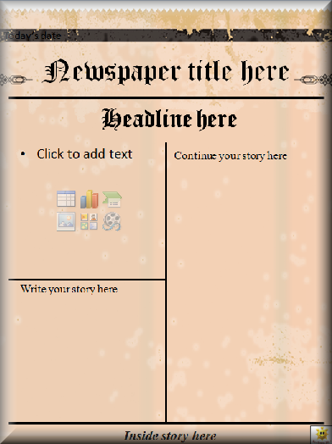
Write Your Own Newspaper Article
Total Points=_________/25
5 - Headline: Byline:
5- Photo
Lead Paragraph: Answer the following questions for the lead paragraph:
5- Who? What? Where? When? Why? or How?
5- Interview character 1: Quotation:
5- Interview character 2: Quotation:

Journal Scoring Rubric
part 1_________, part 2________, part 3_________ Total ______________/90
Scoring Rubric  10 X 9 = 90 | (excellent) 10-9 | (good) 8-7-6 | (satisfactory) 5-4-3 | (needs improvement) 2-1-0
Time Period relevance | Journal is relevant to the time period of both the novel’s setting and the character’s point of view. Includes dates | Journal is somewhat relevant to the time period of both the novel’s setting and the character’s point of view. Includes dates | Journal not very relevant to the time period of both the novel’s setting and/or the character’s point of view. Missing a few dates or dates are incorrect | Journal not at all relevant to the time period of both the novel’s setting and/or the character’s point of view. No dates or dates are incorrect.
Structure,  Creativity, and Presentation | Journal has 9 entries, is neatly constructed, and demonstrates superior attention to detail and creative components | Journal has 9 entries, is neatly constructed, and shows attention to detail and creative components. | Journal has 9 entries and shows some attention to detail with some creativity | The organization of the journal is weak lacks creativity Journal is passed in without any additional components or in disarray.
Descriptive Language: Voice and Plot Events | Includes 9 well-developed journal entries that demonstrate superior understanding of the character’s voice and the events in the story. Each entry addresses three or more of the framing questions providing details and depth. | Includes 9 journal entries that demonstrate understanding of the character’s voice and the events in the Novel. Each entry addresses at least two or more of the framing questions. With some details | Includes 9 journal entries, some demonstrate some basic understanding of character’s voice and plot of the novel. Too few or too many sentences. The entries do not answer more than one of the framing questions or provide details. | Journal entries show weak character voice or weak understanding of the novel’s plot events. Too few or too many sentences and/or do not use the framing questions.
Appropriate Colloquial language | The use of “Dickens” English is effectual. The conventions are appropriate to the character’s age, education, and social status. | The use of “Dickens” English is appropriate. The conventions are somewhat appropriate to the character’s age, education, and social status. | Limited use of “Dickens” English. The conventions are not appropriate to the character’s age, education, and social status. | No use of “Dickens” English. The conventions are not appropriate to the character’s age, education, and social status.
Spelling, Conventions and Grammar | Journal has 9 entries, is neatly constructed, and exhibits correct grammar. | Journal entries follow most grammar rules some proofreading is required. | Journal entries require proofreading and editing. | Journal entries require grammar rules review and editing.
3 Blog Posts
Total Points
5 points each= _________/30

􏰀 Draw, create, collect, or find at least 3 souvenirs that the main character would have put in a scrapbook.  These objects should reflect events in the story or important aspects of your character.
5 post 1______ 5 post 2_____ 5 post 3______
􏰀 The souvenirs/mementos need to be included in the scrapbook and include an explanation next to each object describing its significance.
5 post 1______

5 post 2_____
5 post 3______

Three Pictures of your character
Picture 1________, 2________, 3________. =______/ 6 points
With a quote from that part of the book that best illustrates the character. Be sure to include page numbers!
Total Points
=_________/15
Quote with page numbers 1________, 2________, 3________ /9 points
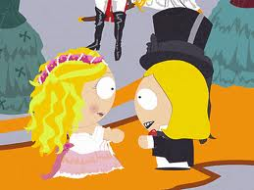
Picture of your character from the beginning of the novel

Quote from this part of the book that best illustrates the character. Page _______
Picture of your character from the middle of the novel

Quote from this part of the book that best illustrates the character. Page _______

PP
Picture of your character from the end of the novel

Quote from this part of the book that best illustrates the character. Page _______

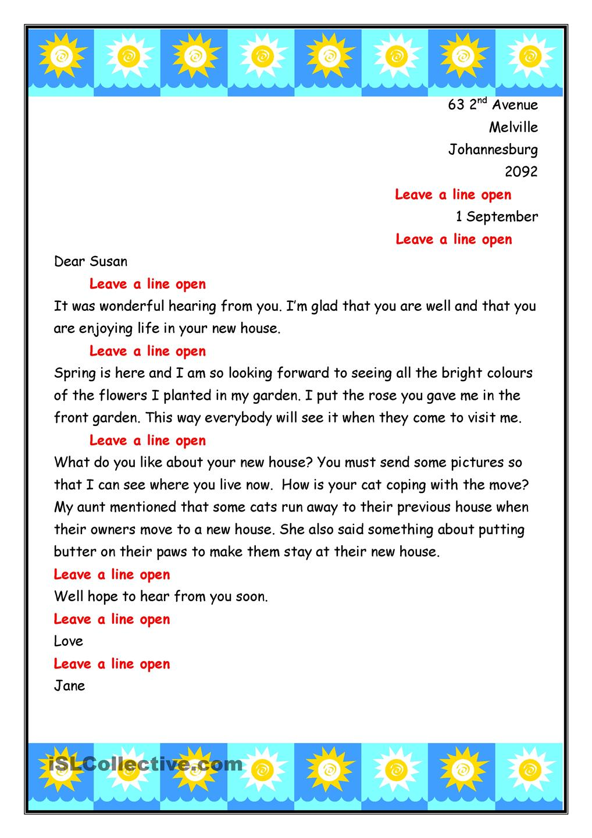
Letter from your character
Write a one-page letter the main character might to send another character.
You are to write a letter from the point of view of your character from Great Expectations. You may choose who the letter will be addressed to, but the letter must coincide with the plot of the novel. This strategy allows you to look beyond what is written in the novel and process what you have read.
5 points = There should not be incongruence between what is described in the story (characterization, setting, mood, etc) and the letter written.
5 points= Students should show that they understand the basic themes, settings, mood, and characters in their letter. Students should also be both realistic and creative.
5 points= Your letter should reflect the main character’s personality and include an actual events of the story. Be sure to include details of the setting, characters, conflict and theme of the story.
5 points= The use of “Dickens” English is effectual. The conventions are appropriate to the character’s age, education, and social status. Appropriate Colloquial language

Total Points=_________/25

Suggested Completion Date: _________
- What was the character like in the beginning of the novel? What did they value? How have they changed?
- (5 points)

- What was the character like in the middle of the novel? What did they value? How have they changed?
- (5 points)

- What was the character like in the end of the novel? What did they value? How have they changed?
- (5 points)

Total Points=_________/20

Personal reflection
How does your character’s actions and personality reflect the novel’s enduring question of social status and prestige?
- (5 points)
How has your character’s actions and personality changed over the 3 parts of the novel?

