Name ______________________________________________
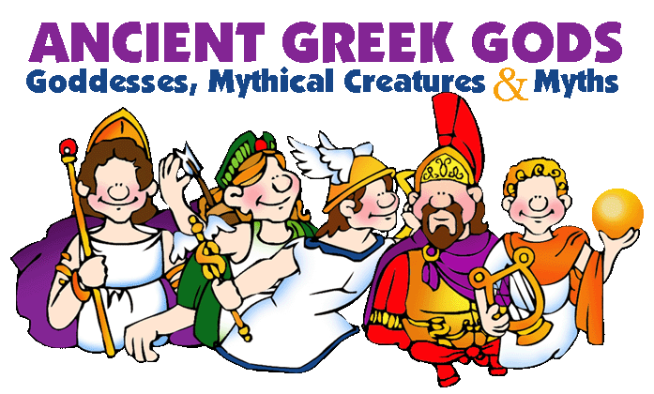
Period __________

Date Assigned | Page(s) | Due Date

Pre-reading Vocabulary Worksheets
- Mythology SPECIAL MYTHOLOGICAL TERMS
Introduction Part I: Using Prior Knowledge and Context Clues Below are the sentences in which the vocabulary words appear in the text. Read the sentence. Use any clues you can find in the sentence combined with your prior knowledge, and write what you think the underlined words mean on the lines provide.
1. Greek and Roman mythology is quite generally supposed to show us the way the human race thought and felt untold years ago. __________________________________________________________________________________________________________________________________________________________
2 & 3. Anyone in the woods might see through the trees a fleeing nymph, or bending over a clear pool to drink, behold in the depths a naiad’s face. ______________________________________________________________________________________________________________________________________________________
4. In Egypt, a towering colossus, immobile, beyond the power of the imagination to endow with movement. ______________________________________________________________
____________________________________________________________________________
5. Nevertheless he was not omnipotent or omniscient either. He could be opposed and deceived. __________________________________________________________________________________________________________________________________________________________
6. ...a humanized world, men freed from the paralyzing fear of an omnipotent Unknown. __________________________________________________________________________________________________________________________________________________________
7. The fauns were Roman satyrs. _____________________________________________________________________________
8 & 9. Dwelling in Olympus, they are happy all their days, feasting upon nectar and ambrosia.__________________________________________________________________________________________________________________________________________________
10. The dryad who would have perished with it told him to ask anything he desired and she would give it to him.
____________________________________________________________________________

Pre-reading Vocabulary Worksheets - Mythology Special Mythological Terms continued Part II: Determining the Meaning Match the vocabulary words to their dictionary definitions.
1. Mythology, 2. nymph, 3. naiad, 4. colossus, 5.omniscient, 6. omnipotent 7. satyrs, 8. nectar, 9. ambrosia, 10. dryad, 11. nymph
A. all-powerful _____
B. stories of the origin of a people, their gods, and heroes ____
C. the food of the gods, thought to give immortality ____
D. having a human body with ears, legs, and horns of a goat ____
E. knowing everything ____
F. a female spirit that represents nature ____
G. the drink of the gods; the undiluted juice of a fruit ____
H. a spirit that lives in brooks and springs ____
I. a huge statue ____
J. a wood nymph ____

Reading Guide Short Answer Questions
Chapter 3 How the World and Mankind Were Created
Chapter 4 The Earliest Heroes

- What did the Greeks think was at the very beginning of things?

2. What were the next six creations, in order?

3. Who was Cronus, and why was he significant?

4. How did Zeus become the ruler of heaven and earth?

5. Describe the Greek concept of the geography of the Earth.

6. Briefly retell the story of Prometheus’s creation of mankind.

7. Who was Pandora, and why was she created?

8. Briefly retell the story of Pandora’s box.

Prometheus and IO
______________________________________
1. How and why did Io suffer?
2. Who was the source of both Io and Prometheus’ problems?
3. Why do the feathers of peacocks seem to have eyes?
4. What region and body of water are named for Io?
5. Io will be the mother of what two sons?
6. What makes Io a heroine?
7. Why did Zeus punish Prometheus, and how did he do this?
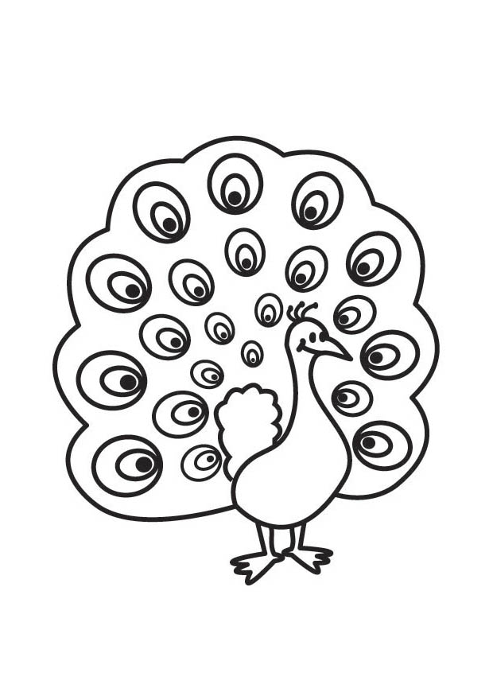
Europa
______________________________________
1. How did Zeus seduce Europa?

2. Describe Europa’s fate.

3. What special roles do two of Europa’s sons play?

4. Briefly retell the story of Europa.

Narcissus
_________________________________________
1. What is the story of Narcissus?

2. What part does Narcissus play in the Persephone story?

3. Describe Narcissus.

4. What role did Hera play in the Narcissus and Echo story?

7. How does the English word, echo, relate to the Greek goddess, Echo?

8. Who was Echo?

9. How are the stories of Persephone and Echo similar in regard to Narcissus?

10. Summarize the the story of Adonis.

Pre-reading Vocabulary Worksheets - Mythology Part One The Gods, The Creation, and the Earliest Heroes
Chapter 3 How the World and Mankind Were Created Chapter 4 The Earliest Heroes Introduction
Part I: Using Prior Knowledge and Context Clues Below are the sentences in which the vocabulary words appear in the text. Read the sentence. Use any clues you can find in the sentence combined with your prior knowledge, and write what you think the underlined words mean on the lines provided.
1. Erebus is the unfathomable depth where death dwells. __________________________________________________________________________________________________________________________________________________________
2. Groans shall your speech be, lamentation your only words. __________________________________________________________________________________________________________________________________________________________
3. It looked like a heifer, but talked like a girl who seemed mad with misery. __________________________________________________________________________________________________________________________________________________________
4. You-he who succored the whole race of men? __________________________________________________________________________________________________________________________________________________________
5. Swells on a ship, and ever gently thus they wafted her. _________________________________________________________________________________________________________________________________________________________
6. He bade each man choose out three rams and bind them with strong, pliant strips of bark. __________________________________________________________________________________________________________________________________________________________
7. Her voice would ring in his ears calling him a laggard in love. __________________________________________________________________________________________________________________________________________________________
8. The contrast of this laughing, luxuriant beauty with the clear-cut, austere grandeur all around arrests the attention sharply.
__________________________________________________________________________________________________________________________________________________________

Part II: Determining the Meaning Match the vocabulary words below to their dictionary definitions continued on the next page

1. Unfathomable _____
2. lamentation _____
3. heifer _____
4. Succored _____
5. wafted _____
6. pliant _____
7. laggard _____
8. austere _____

A. Assisted, helped
B. Foated gently and smoothly
C. Severe, having no decoration
D. Not able to be understood
E. A song or poem that expresses grief or mourning
F. Easily bent
G. Straggler
H. A young cow, especially one that has not given birth

Pre-reading Vocabulary Worksheets - Mythology Part Two Stories of Love and Adventure
Chapter 5 Cupid and Psyche Chapter 6 Eight Brief Tales of Lovers
Introduction Part Using Prior Knowledge and Context Clues Below are the sentences in which the vocabulary words appear in the text. Read the sentence. Use any clues you can find in the sentence combined with your prior knowledge, and write what you think the underlined words mean on the lines provided.
1. She seemed a very goddess consorting with mere mortals. __________________________________________________________________________________________________________________________________________________________
2. ...to do her homage as though she were in truth one of the immortals. __________________________________________________________________________________________________________________________________________________________
3. “But really,” she said, “you are so plain and ill-favored a girl that you will never be able to get you a lover except by the most diligent and painful service.”
__________________________________________________________________________________________________________________________________________________________
4. No; he was a horrible serpent and she loathed him. __________________________________________________________________________________________________________________________________________________________
5. She offered ardent prayers to them perpetually, but not one of them would do anything. __________________________________________________________________________________________________________________________________________________________
6. The conclusion was inevitable. __________________________________________________________________________________________________________________________________________________________
7. She ventured to go back to the tree of the tryst, the mulberry with the shining white fruit. __________________________________________________________________________________________________________________________________________________________
8. She determined to help a young man who could be enamored and yet original. __________________________________________________________________________________________________________________________________________________________
9. The alliance had become eminently suitable. __________________________________________________________________________________________________________________________________________________________
10. Such was the wondrous power of this disdainful young man. __________________________________________________________________________________________________________________________________________________________
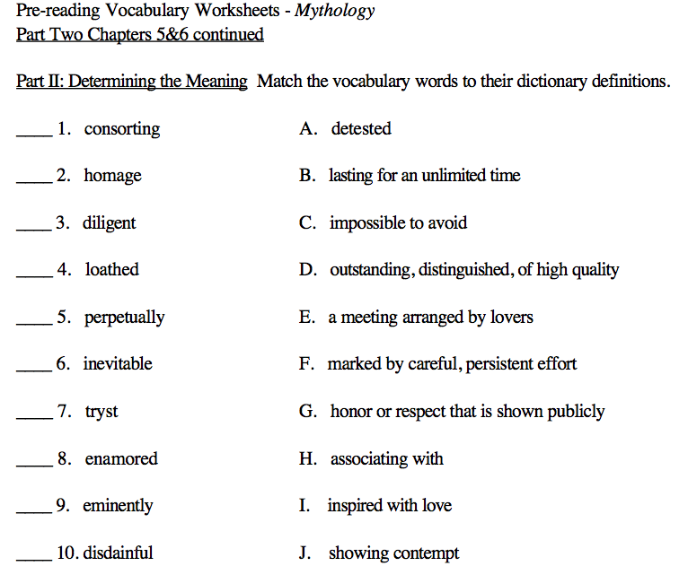

Part Two Stories of Love and Adventure
Chapter 5 Cupid and Psyche
_______________________________________
1. Why was Venus angry at Psyche?
2. Was Venus’s plan for revenge successful?
3. What did Psyche discover about her mysterious husband, and what happened when she discovered it?
4. What finally happened to Cupid and Psyche?

Chapter 6 Eight Brief Tales of Lovers
_____________________________________________

5. Which lovers arranged a tryst, mistakenly thought the other had been killed, and killed themselves?
6. Identify the lovers in the following summary. He was the son of one of the Muses, and a gifted musician. She died on their wedding day. He went to the underworld and tried, unsuccessfully, to bring her back.
7. This man was killed at sea. Morpheus appeared to his wife and told her that her husband was dead. Then she and her dead husband were turned into birds.
8. He fell in love with a statue that he had made. Venus brought the statue to life and they married. Who were they?

9. What did Baucus and Philemon do?

10. Apollo fell in love with this daughter of the river god Peneus. She did not love him. To protect her, her father turned her into a laurel tree. Who was this?
Part Two Stories of Love and Adventure continued Chapter 7 The Quest of the Golden Fleece Chapter 8 Four Great Adventures
- Why was Jason’s journey significant?

- What was the origin of the Golden Fleece?

- Why did Jason undertake the search for the Golden Fleece?

- What were the Harpies, and how were they destroyed?

- Name Jason’s ship and at least one of the heroes who traveled with him.

- Who were the Amazons?

- What task did Jason have to perform for King AEetes in order to get the Golden Fleece?

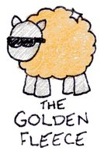
- Who helped Jason, and why?

- Who were Pegasus and Bellerophon?

- Which father and son used wings made by the father to escape from the Labyrinth, and were they successful?

Pre-reading Vocabulary Worksheets - Mythology Part Three The Great Heroes Before the Trojan War
Chapter 9 Perseus Chapter 10 Theseus Chapter 11 Hercules Chapter 12 Atalanta
Introduction Part I: Using Prior Knowledge and Context Clues Below are the sentences in which the vocabulary words appear in the text. Read the sentence. Use any clues you can find in the sentence combined with your prior knowledge, and write what you think the underlined words mean on the lines provided.
1. The scudding waves so near your soft curls. __________________________________________________________________________________________________________________________________________________________
2. ...to sail on it would be a contemptible flight from danger. __________________________________________________________________________________________________________________________________________________________
3. He spent a large part of his life expiating one unfortunate deed after another. __________________________________________________________________________________________________________________________________________________________
4. Sometimes he punished himself when others were inclined to exonerate him. _________________________________________________________________________________________________________________________________________________________
5. It would have been ludicrous to put him in command of a kingdom. __________________________________________________________________________________________________________________________________________________________
6. He was helped by Athena to drive them out of their coverts, and as they flew up he shot them. __________________________________________________________________________________________________________________________________________________________
7. One of the poems ascribed to Hesiod describes the race and the golden apples. __________________________________________________________________________________________________________________________________________________________
8. ...who loved adventure as much as the most dauntless hero. __________________________________________________________________________________________________________________________________________________________

1. scudding _____
2. expiating _____
3. exonerate _____
4. ludicrous _____
5. coverts _____
6. ascribed _____
7. dauntless _____
A. absurd, incongruous
B. skimming along swiftly and easily
C. attributed to
D. fearless, not intimidated
E. to free from blame
F. despicable
G. making amends, atoning
H. thick underbrush offering shelter for game

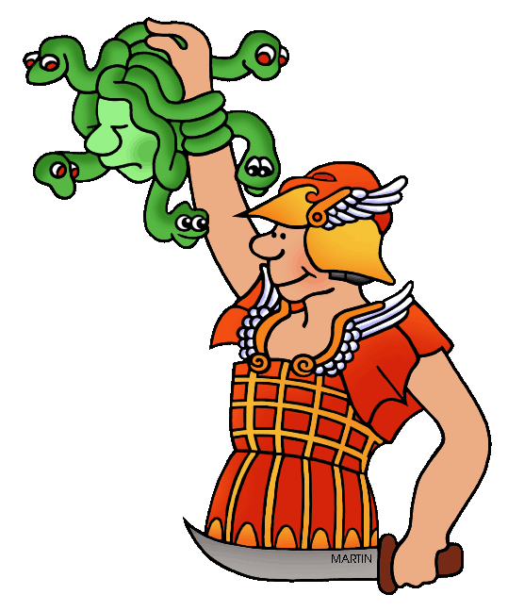
Part Three The Great Heroes Before the Trojan War
Chapter 10 Theseus , Chapter 11 Hercules , Chapter 12 Atalanta

Chapter 9 Perseus
___________________________________________

- How is Perseus’ birth magical?

- What was the Medusa, and how did Perseus kill it?

3. How did Perseus use Medusa’s head to help his mother?

Compare events in Perseus’ life to the following elements of a “Cinderella” story:
- Cinderella’s fairy godmother gives her a ball gown and a coach.

- Cinderella has certain rules to follow, such as leaving the ball by midnight

- Cinderella is rescued from a miserable life by her fairy godmother.

- Cinderella gets the prince in the end.

Chapter 10 Theseus
________________________________________________
- Theseus was raised in a city away from his father, King Aegeus of Athens. How did the King know that Theseus was his son when they finally met?

- What was the Minotaur, and how did Theseus kill it?

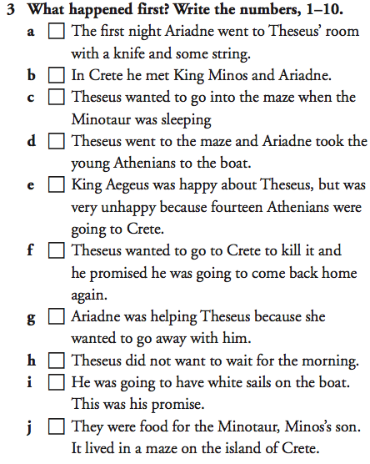

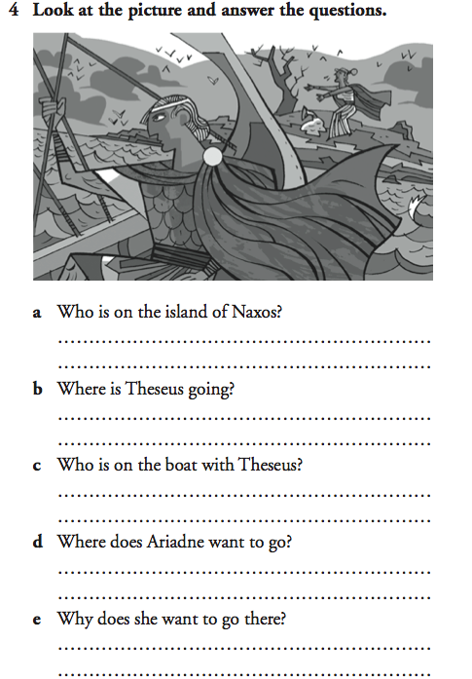
5. How did Theseus change the government when he became King of Athens?

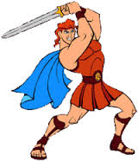
Chapter 11 Hercules Chapter 12 Atalanta
____________________________________________________

- Who was the strongest man on earth, and the great hero of Greece except for Athens?

- Why did Hercules perform his twelve labors?

3-14. List the twelve labors of Hercules.
1 | 7
2 | 8
3 | 9
4 | 10
5 | 11
6 | 12

- Whom did Atalanta tell her father she would marry?

- Whom did Atalanta marry, and how did he win her?

Mythology Biographical Poem
A biographical poem, or biopoem, uses a simple but specific structure to describe the most important facts about someone. Your assignment is to write a biopoem about one of the gods or goddesses you have studied. You may choose any god or goddess. The blanks on this page are for your rough draft. When you’re done, copy your final version onto a separate sheet of paper and decorate it, if you would like. Follow this format exactly, please:
Greek Name__________________,
I am (list four traits) ___________, ____________, __________, ___________.
I am a relative of (1-3 people) ________________________________________.
Lover of (1-3 things or people) ________________________________________.
Who feels/protects (1-3 things) ________________________________________.
Who needs (1-3 things) __________________________________________.
Who fears (1-3 things) __________________________________________.
Who gives (1-3 things) ___________________________________________.
Resident of _____________________,
Roman Name__________________.
Mythology Biographical Poem Scoring Rubric
5 Contains all required elements
5 Correct format
5 Neatly written or typed
5 Demonstrates insight into god or goddess
5 Creativity
_____________/25

