GREEK MYTHOLOGY
Background to Homer’s Odyssey

As you read each story, ask yourself:

What is most enjoyable, predictable, or bizarre about this story?

How would I have responded in this situation?

What mysteries or features of the world might this story try to explain?

What bit of moral or religious instructions (i.e. don’t disobey the gods) might be contained in this story?

How does this story compare with Christian beliefs, or with the values of our culture today?
Are there any other stories or fables I’ve heard that follow the same pattern as this story?

The Creation Myths

Part 1

Before there was anything, there was Chaos, a formless void. This void, this pure nothingness, gave birth to Gaea (the Earth itself), Tartarus (the underworld), Eros (love), Erebus (underground darkness) and Nyx (the darkness of night). The two kinds of darkness joined together and gave birth two kinds of light: the Light of the heavens and the Light of day. Nyx (night) also gave birth to the three Fates, who control the course of the universe and determine the length of each person’s life on their wheel of fortune. Of the fates, Clotho spins the threads of each person’s life, Lachesis measures the length of the thread, and Atropos cuts the thread.
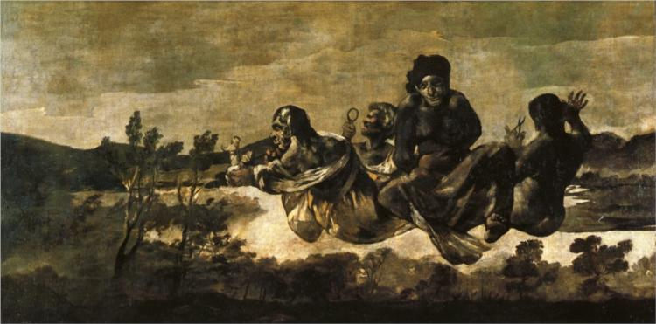

The Fates – Francisco Goya (one of the best painters ever!) 1823 – Note the scissors in the hand of Atropos and Lachesis measuring with a magnifying glass. Who’s the fourth one? Another fate? Gaea, their mother?
Part 2 – The marriage of Gaea to her son Uranus spawns the Titans

Gaea, “Mother Earth,” gave birth without conceiving to the starry Heaven (Uranus), to the Mountains, and to the Sea. Then, Earth married Heaven: Gaea married her own son Uranus, and from this were born a generation of powerful gods known as the Titans, the elemental forces and pieces of creation. The titans include the river gods and the Ocean itself, the Moon, the four winds, Helios, the sun god, lovely Dawn, who starts each day waking fresh and rose-fingered, Cronus (Saturn), who rules time, and Rhea, Cronus’ sister.
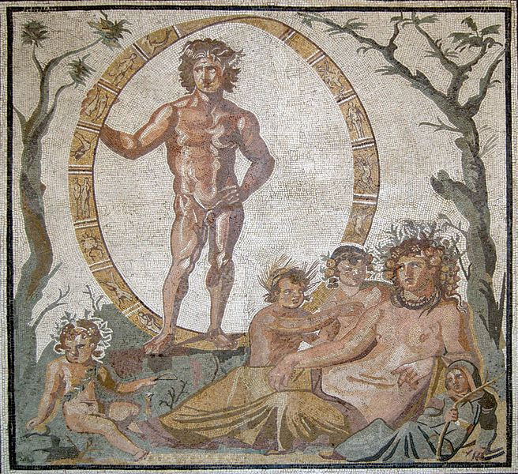

Uranus with Gaea, his mother and wife (and with baby titans?)

Other Titans control the basic elements of human civilization: Themis the goddess of Justice, Metis, or Wisdom, and the Muses, who inspire artists. The offspring of the Titans in turn included the brothers Prometheus and Epimetheus.

Part 3 – The first father-son conflict: Uranus vs. Cronus

The offspring of Gaea and Uranus, included not just the titans, but also hideous monsters: the three Hundred-Handers (which also had 50 heads each) and the one-eyed Cyclopes. Uranus, appalled at the sight of his ugly offspring, hurled them into Tartarus, the underworld. Gaea, their mother, was outraged at Uranus and vowed revenge. Secretly, she convinced her son Cronus to avenge his father’s cold-heartedness. Cronus waited until Uranus was about to lie with Gaia; then, he leaped at Uranus and castrated him with a sickle, throwing his genitalia into the sea. The drops of blood from the castration emerged from the sea as the hideous Furies, winged women with snakes for hair who haunt those who have killed a family member. The genitalia themselves foamed up and emerged from the sea as Aphrodite, the incredibly beautiful goddess of love, who washed up on the shore of Cyprus. Uranus himself was banished to Tartarus and produced offspring no more.
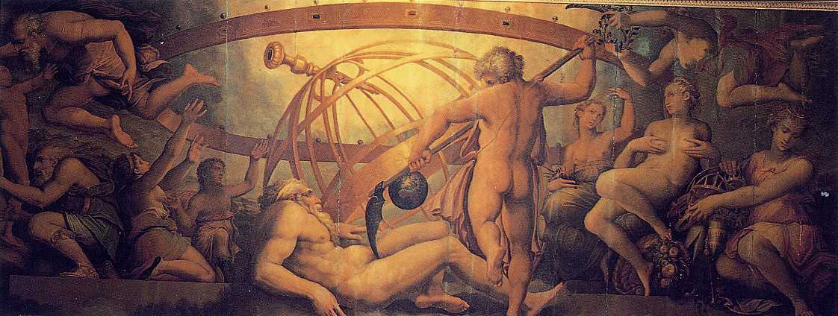

The castration of Uranus by Cronus (The mutilation of Uranus by Saturn – Giorgio Vasari). Note the scythe.

After overthrowing Uranus, Cronus married his sister Rhea and took control of the world. Having seen what happened to his father, Cronus worried that something similar might eventually happen to him.

Part 4 - The father-son conflict repeats itself: Cronus vs. Zeus
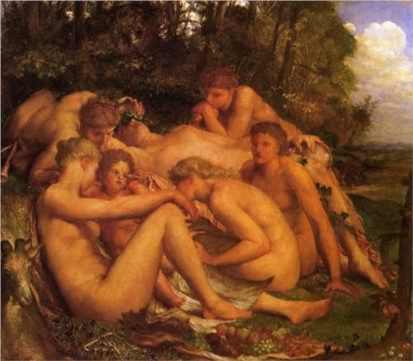
The period of Cronus’ rule was known as the Age of the Titans. Cronus ruled supreme, yet he received a prophecy that his son would betray him. To prevent this, every time Cronus’ wife Rhea gave birth, Cronus immediately swallowed the child. He consumed five of his offspring in this manner, Poseidon, Hades, Demeter, Hestia, and Hera. Trapped inside Cronus’ stomach, the immortal god-babies grew and grew – but they could never escape.

Infancy of Zeus – George Frederick Watts

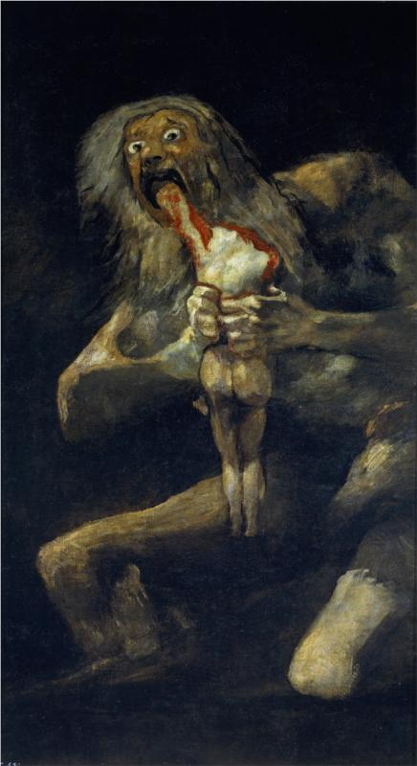

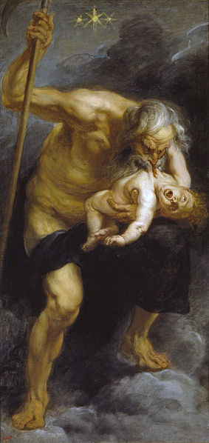

Above: Cronus devours Poseidon – Peter Paul Rubens. Note the scythe. (click here for full-size and zoom in. You’ll be glad you did:
http://upload.wikimedia.org/wikipedia/commons/d/dd/Rubens_saturn.jpg)

Right: “Saturn Devouring his sons.” Francisco Goya. Click here for full size: (http://uploads6.wikipaintings.org/images/francisco-goya/saturn-devouring-one-of-his-children-1823.jpg!HD.jpg )

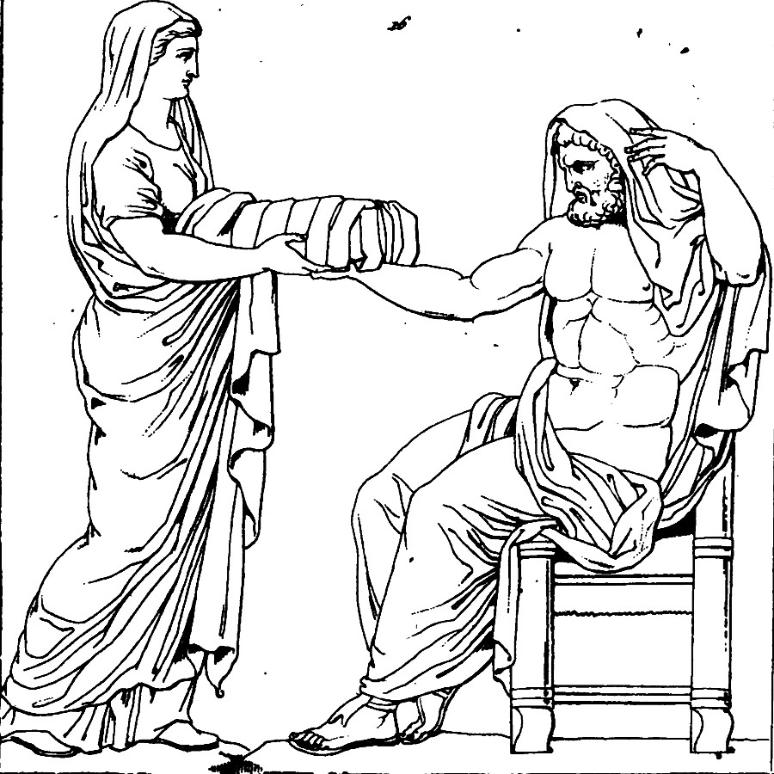

Rhea, the wife of Cronus, was angry that her husband was swallowing their children, so when the sixth child, Zeus, was born, she quickly gave him to some nymphs to be raised in a cave. Then, she gave her husband a rock wrapped in a blanket to swallow in place of Zeus. Zeus grew up into a powerful god; he and Rhea gave Cronus a potion which made Cronus vomit up the other five offspring; and war immediately broke out between the father and his children.
Rhea gives to Cronus a rock wrapped in a blanket to swallow.

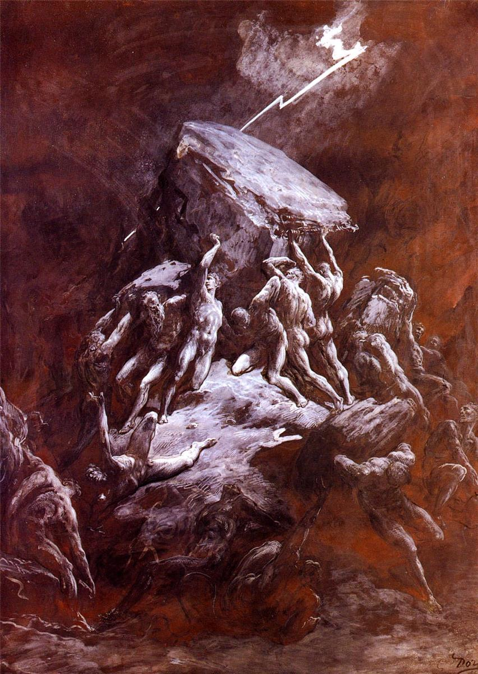
Part 5 – The Clash of the Titans

The Clash of the Titans – Gustave Dore 1866

Part 5 -Clash of the Titans
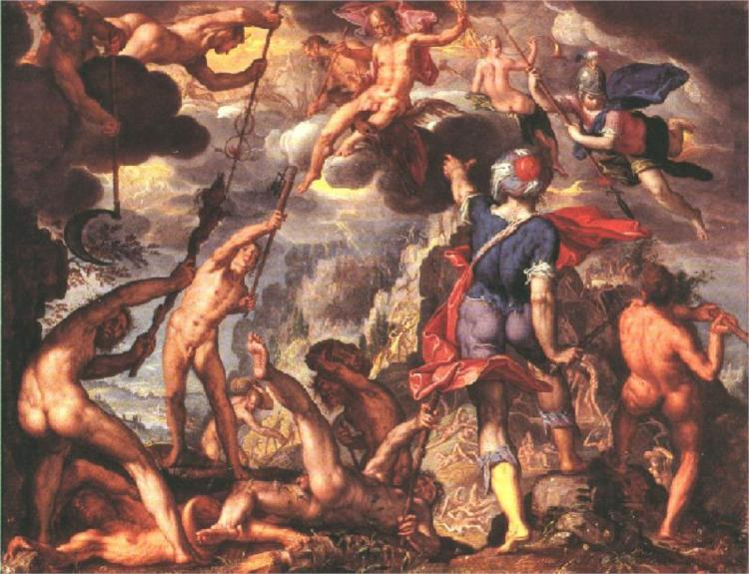

The massive war between Cronus and Zeus lasted ten years. Most of the Titans supported Cronus. Zeus and his siblings got the help of Prometheus, who released the Hundred-Handers and the Cyclopes from Tartarus. The Hundred-handers threw boulders to help the Olympians, while the Cyclopes gave Zeus and his brothers powerful weapons: to Zeus they gave thunder, lightning, and the thunderbolt; to Poseidon, the trident, a three-pronged spear; and to Hades, a helmet to make him invisible. These gifts gave Zeus and his generation enough of an advantage to finally defeat Cronus. The victorious gods of Zeus’ generation banished all of the losing Titans to Tartarus, except for Prometheus, Epimetheus, and Atlas, the muscle-bound god who was sentenced forever to support the world on his back.
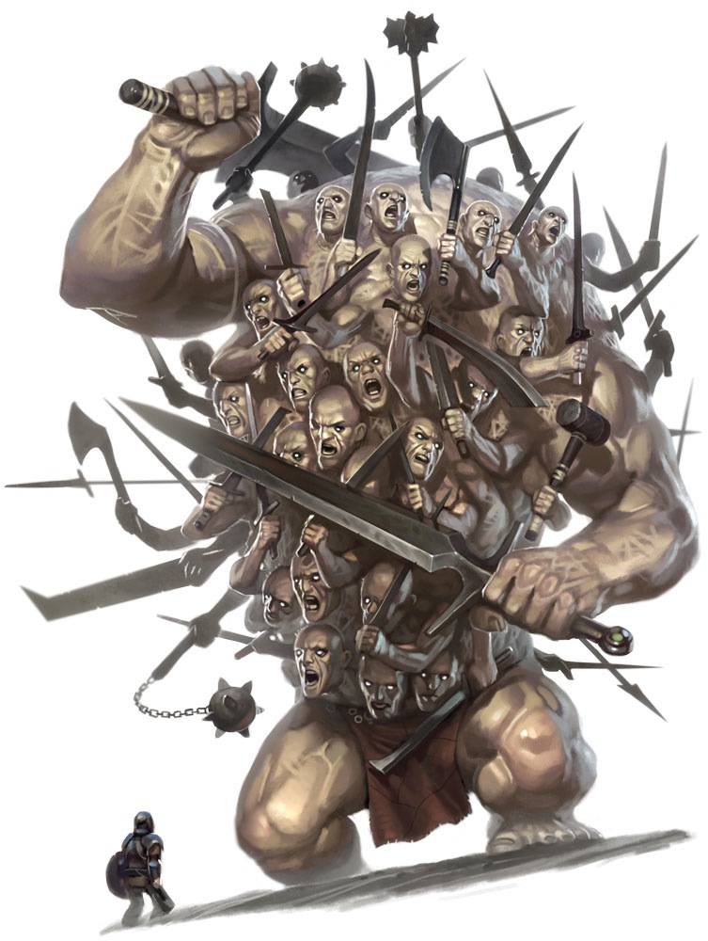

To remember this order, the order of the three largest planets follows along with the sequence of sons overthrowing their fathers. From our perspective on Earth, Jupiter (Zeus) stands in front of Saturn (Cronus), and Saturn in turn stands in front of Uranus.

TOP RIGHT: The battle between the gods and the titans. Joachim Wteweal 1600.

Right: hundred-hander, or Hekatonkheires – (from http://images2.wikia.nocookie.net/__cb20120323052952/warriorsofmyth/images/3/3c/PZO1120-Titan_Hecatonchires_Hecatoncheir_Hecatonchire_Hekatonkheires_Hekatonkheir_Centemani_Hundred_Handed_Greek_Mythology_Myth_Monster-1-.jpg

Commentary: Significance of the Creation stories:

All of the natural forces and parts of the world, along with the basic things needed for human civilization are explained in these stories. We see that prophecies of doom (such as Cronus’) can never be circumvented. We see that sons often overthrow their fathers, and that the Greeks are fascinated by father-son and mother-son relationships. Greed is punished, even among the gods. Gods, once born, are immortal; they can be overthrown but never completely destroyed. Cruel punishments are, for the Greeks, an acceptable fate for those who go against the proper order of things. Trickery is also an acceptable means of defeating an enemy.
Jupiter and Thetis – Jean Ingres 1811
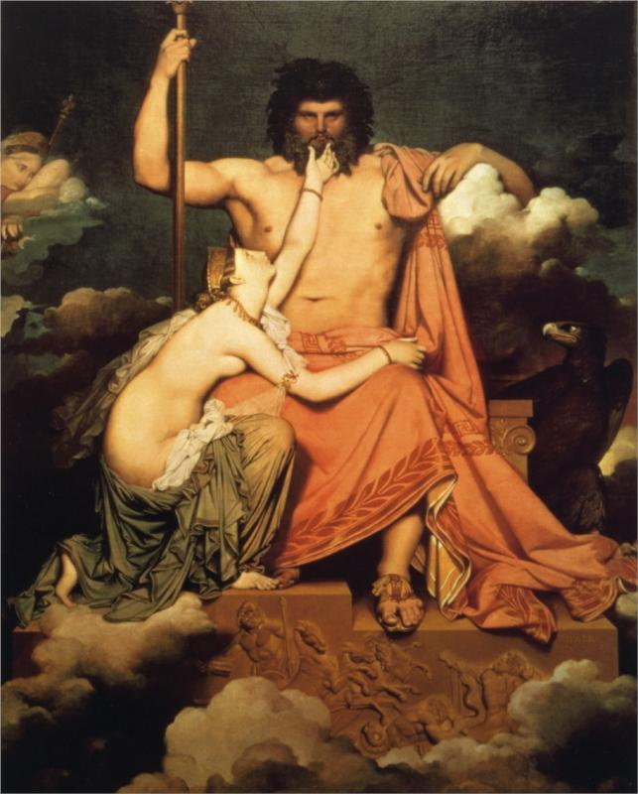
Zeus in Charge: The Olympian Gods

After Zeus defeated Cronus, he and his brothers divided the universe among them. Zeus was ruler of the heavens, Poseidon ruled the sea, and Hades was king of the underworld. Earth belonged to all of them. Zeus invited twelve gods to live with him on Mount Olympus. These gods became known as the Olympian gods, and the Greeks considered them the highest-ranking gods. (Later Dionysus, god of wine and drama, was added to the list.)

Here are the Olympians:

Zeus is king of the gods. He rules the heavens; he rewards those who show hospitality. He wields lightning and carries an aegis, or shield. The eagle is associated with Zeus. Zeus is often overcome with desire for beautiful females and ends up being unfaithful to his wife Hera. In Roman mythology, Zeus is known as Jupiter or Jove.

Hera is Zeus’ sister and his wife. Because Zeus cheats on her so much, she is known for her jealousy. You may remember Hera as the goddess who made things difficult for Hercules. She resented Hercules because he was the result of yet another of Zeus’ extramarital affairs. Surprisingly, the Greeks also considered Hera the patron of marriage! Hera’s Roman name was Juno.

Because Zeus was so often unfaithful to Hera, he had many, many, illegitimate offspring. Four of these were counted among the Olympian gods:

Athena is Zeus’ favorite daughter, born from Zeus’ own forehead after he swallowed her mother Metis while she was pregnant with his child. Some time after swallowing Metis, Zeus developed a tremendous headache. Hephaestus cracked open Zeus’ skull with a hammer, and out came Athena. Athena is goddess of wisdom (and weaving), generally generous-natured, known for her flashing eyes and for her ability to take on many disguises. Athena is associated with weaving probably because it takes so much concentration to create an intricate woven pattern. In Roman myths, Athena is known as Minerva.

Apollo and Artemis are Zeus’ powerful twin children (their mother was Leto, daughter of the Titan Phoebe).

Apollo, who guides the sun across the sky each day with his chariot, is god of truth, light, and justice; he also is the patron of musicians and doctors. Prophets are often portrayed as being priests of Apollo. The Romans, being devoted to the law, admired Apollo so much that they didn’t bother to change his name. Apollo is often called Phoebus Apollo, or just Phoebus, after his Titan grandmother Phoebe. Apollo had a temple in Delphi where one could consult an oracle to get Apollo’s advice before making an important decision. (these will be important in the Oedipus plays, which you will read next year as a sophomore.) Apollo is associated with the sayings “Know thyself” and “Nothing to excess.” He personified the Greek ideal of moderation, known as “the golden mean.”

Artemis is associated with the moon and with hunting. She helps virgins remain chaste. Her invisible arrows can bring instant death to humans (the etiology of heart attacks). Artemis was known as Diana to the Romans. She will play a role in one character’s back story later on in the Odyssey.

Hermes - son of Zeus and Maia (daughter of Atlas), is the fleet-footed messenger of the Olympian gods. He has special winged helmet and sandals. Known for his fun-loving nature, he loves trickery and is the patron of thieves. He will help you if you want to get “something for nothing.” In Roman mythology, Hermes goes by the name of Mercury.

Zeus and Hera did manage to have two sons together, Hephaestus and Ares.

Hephaestus was born deformed; Hera threw him off Olympus, so he’s crippled. He’s the master metalworker among the gods; he makes swords, shields, cups, bowls, helmets, spears, etc.; sometimes these are given as gifts or rewards to heroic humans. Hephaestus is ugly, but he gets to be married to the most beautiful goddess, Aphrodite. The Romans called this master metalworker Vulcan and held him responsible for volcanoes.

Ares is the nasty god of War, who takes pleasure in causing animosity and strife among humans. The Greeks were not fond of Ares, but the Romans, being more warlike, loved him. They called him Mars.

Poseidon is one of Zeus’ older brothers. He is the powerful and short-tempered ruler of the Sea. With his trident, he stirs up the sea to produce sudden storms that can bring death to unwary sailors. He also uses his trident to make earthquakes. He is the father of a Cyclops named Polyphemus whom Odysseus encounters on his journey. If you want to be able to survive encounters with anything unpredictable in nature (which includes horses and earthquakes), Poseidon is the god to whom you’d better offer libations and sacrifices. Zeus, being the younger brother, has a hard time getting Poseidon to do what he wants. Poseidon has a second palace of his own under the sea. The Romans called him Neptune.

Hestia and Demeter are Zeus’ other two sisters. In a sense, they are probably the most ancient of the Olympian gods in terms of their origins in Greek religious beliefs.

Hestia probably dates back in some form to the discovery of fire. She is the goddess of the hearth. When properly placated, Hestia makes sure that the fires at each town’s common hearth and in each family’s home do not go out during the night. Hestia is quiet and modest; she supports all domestic activities. The Roman name for Hestia is Vesta. “Vestal virgins” were young maidens dedicated to Vesta, herself a virgin.

Demeter probably dates back to the dawn of agriculture. She is the vitally important goddess of agriculture and of the harvest. She doesn’t appear that often in the myths although she is sometimes depicted during the fall spilling out the contents of a cornucopia, a cone-shaped basket of vegetables, fruits, grain, etc. When Demeter’s daughter Persephone goes to spend four months of the year as the wife of Hades, Demeter becomes so despondent that no plants will grow. The Romans called her Ceres, and the cereal you eat at breakfast takes its name from her.

Aphrodite is the only member of the Olympians who is not in Zeus’ generation or the generation below Zeus. Aphrodite, the goddess of love, is the offspring of Uranus, “born” when his genitalia fell into the ocean. She is married to Hephaestus. She was be responsible for the start of the Trojan War (see below). According to one version of things, Eros (a.k.a. Cupid) is her son. He’s the one who shoots the golden arrows that make people fall in love with the first person they see (as well as the leaden arrows that make people despise the first person they see). The Romans called Aphrodite Venus.

Dionysus, god of wine and drama, is also considered an Olympian god. Dionysus is a later addition to the pantheon of Olympian gods – probably introduced when the Greeks learned to cultivate grapes. He’s yet another illegitimate offspring of Zeus. Female followers of Dionysus called maenads (the name means “madwoman” in Greek) engaged in wild wine-drinking parties in the woods; these parties sometimes turn into out-of-control orgies. Eventually the worship of Dionysus was brought under control and transformed into choral songs and dances; these gradually developed into what we now call drama. So Dionysus is also the god of Drama. Dionysus was referred to as Bacchus by the Romans, and the wild drinking parties were called bacchanalia. If Apollo represents the golden mean, Dionysus represents just the opposite!

The Underworld

Hades is the only one of Zeus’ brothers and sisters who does not reside on Mount Olympus. At the end of the war with the Titans, Hades chose to rule the Underworld. The name for the Underworld itself came to be Hades. Hades is a cold, stern individual who wears a helmet that makes him invisible. To the Romans, Hades was known as Pluto. He was associated with mining and mineral wealth, for obvious reasons. The coldest, darkest of our planets (and yes, it is a planet) is named for him.

Hades (the place) is not the same as the Christian image of hell. Hades is a somber place of eternal repose, neither happy nor painful, where the souls of the dead remain forever, discussing the triumphs and mistakes of their lives until they drink enough water from the river of Lethe (forgetfulness) that they can’t remember anything anymore. One of the ways to reach Hades involves crossing the river Styx with the help of a ferryman, Charon. A vicious three-headed dog, Cerberus, guards the entrance to Hades.

Few humans visited Hades and returned to tell about it. Exceptions include Orpheus, who charmed both Charon and Cerberus with his music, and Persephone, the daughter of Demeter. It’s worth mentioning their stories briefly:

Orpheus was the world’s greatest musician. When his wife, Eurydice, died suddenly, he missed her so much that he made the journey far down into Hades to request her back. Hades was so charmed by Orpheus’ music that he granted Orpheus’ request, on one condition: Orpheus had to walk in front of his wife as they climbed back up out of Hades, and he was not allowed to look back to see if she was still behind him. Just before reaching the top, Orpheus’ curiosity overcame him. He looked back to see if his wife was behind him, and she immediately fell all the way back down into Hades – for good. The scene probably looked a lot like the death of the Emperor in Return of the Jedi.

Persephone has an even stranger story, but it’s one that explains the change of the seasons. Hades desperately wanted Persephone, the beloved daughter of Demeter, to be his wife. Hades and Demeter agreed that if Persephone ate a certain pomegranate fruit, she would have to live forever with Hades in the underworld. If, however, Persephone did not eat the fruit, she could stay on the surface. As fate would have it, Persephone ate 1/3 of the pomegranate (four of the twelve seeds), so she must live with Hades as his wife for four months of the year. Whenever she’s in Hades, her mother Demeter goes into mourning (thereby causing winter to take over up on the surface).

Tartarus is the part of the underworld most like the Christian conception of hell. Tartarus, known as the Land of the Damned, was reserved for those who had committed serious crimes offending the gods. For examples of such crimes, turn to the stories of Ixion and Sisyphus.
Review Worksheet

The first goddess to be worshipped in ancient times was ________________ also known as Mother Earth or Mother Nature. It was not until much later that _______________, a male god, became the principal _______________ in a pantheon of gods and goddesses.
Gaea was one of the offspring of Chaos. The region under the earth, _______________________, was also one of the offspring of Chaos. Another offspring, _____________ (Night) brought forth three famous daughters called the Three _____________, who controlled the course of the universe. Gaea’s union with her son, ___________________ (the starry heaven) resulted in twelve large, strong children called the _____________________. Among the many significant offspring of these Titans was Eos, also known as _______________.
Gaea and Uranus also gave birth to some not-so-handsome creatures. The ________________ were massive one-eyed monsters, and the ______________________________ had fifty heads and 100 hands.
Uranus was so disgusted by these vile creatures that he threw them into _______________________. This action greatly upset Gaea. Her youngest son, _____________________, agreed to help her get revenge on Uranus. While Uranus was ___________________________________________, Cronus _________________________________________________and threw Uranus’ __________________
into the ______________. A white _____________________ formed from the flesh, which turned into ______________________, the Goddess of ________________ . When a Trojan named Paris later chose her as the most beautiful goddess, this led directly to the outbreak of the Trojan War.
Meanwhile, the drops of __________________ from Uranus caused Gaea to give birth to the ________________, who were winged creatures with ____________________ for hair who pursued ___________________________________________________.

Cronus is still known as “Father ____________” and is often pictured holding his sickle and referred to as the “Grim Reaper.” The word _________________________, meaning “in time order”, comes from the name of Cronus.
Cronus married his sister _____________________, and she gave birth to five children:
_______________________, who would become goddess of ________ and fertility of the land;
_______________________, who would become goddess of the hearth;
_______________________, the eventual wife of Zeus;
_______________________, who would rule the underworld; and
_______________________, who gave the first horse to man and ruled the __________.
Cronus was warned that he would be brought down by a traitorous son, so he ________________________________________________________________________________________________________________________. Rhea prevented ____________________, the sixth offspring, from being treated in the same way. She tricked Cronus by ____________________________ and hiding ____________ in a _____________________________. The Greeks loved stories of trickery like this one.

__________________ was reunited with his five older brothers and sisters when ___________________________________________________________________________________. The six offspring then declared war on Cronus. The war lasted ___________ years. The younger generation became known as the Olympians because they fought from ________ __________________. The Olympians were able to defeat the Titans because a son of a Titan named ______________________ came over to the Olympian side and advised them. Released from Tartarus, the ___________________ gave the gift of __________________________________ to Zeus. They also gave a three-pronged spear, or ______________________, to _________________________. They also gave _________________ a helmet that would make him ___________________________. Also released from Tartarus, the ____________________________threw boulders to help the Olympians defeat the Titans. To this day, the Titans remain in _______________________________, except for _________________________ and ___________________________ (his brother) and ________________________, whose job is to hold up the world. The story of Cronus’ downfall is just one of many in which someone tries to avoid his fate but finds that his fate comes true anyway.

The only offspring of Cronus who did not remain on Mount Olympus was _________________. The other five children of Cronus and Rhea, namely ___________________, ___________________, ___________________, _____________________, and _____________________, were five of the Twelve Olympians.

Our modern word “jovial” comes from the name _______________, which was one of the Roman names for the mightiest Greek god, ____________. If a guest or stranger came to your house and you did not treat him well, you might fear the wrath of ______________ because he is the god of ________________. He carries a thunderbolt and an ______________, or shield. He is often unfaithful to his wife and sister, _______________. Hera, as a result, is constantly feeling _____________________ of Zeus. The most popular month for weddings is still June because Hera was the patron of _______________________and Hera’s Roman name was ___________________.

Poseidon will figure very prominently in the story of Odysseus. With his trident, Poseidon could stir up the seas and _____________________________. Perhaps this is why he is described as being gruff and _______-_____________________. Poseidon was so powerful that he had homes both on _________________________ and in __________________. Poseidon’s offspring included a Cyclops named ___________________________.

____________________________ and __________________________ were twin brother and sister. Their father was _____________ and their mother was ________________, daughter of the Titans Coeus and Phoebe. (“Phoebus”, meaning “born from Phoebe”, is another name for ____________________, the god of truth, light, justice, music, and _______________________. At the temple of Apollo, located in ___________________, one could consult the __________________ to get the advice of Apollo before making an important decision. One saying associated with Apollo is “Know thyself.” Another saying associated with Apollo is “____________________ __________ _____________________.” He personified the Greek ideal of moderation, known as “________ ________________ _______________.” This ideal called upon everyone to follow a middle course and never go to extremes. Many Greek stories, such as the story of Icarus, who flew too high and had his wax-and-feather wings melt from the heat of the sun, teach the ideal of “________ ___________________ ____________________.”

Perhaps the most well-known Greek goddess was _____________________. Her mother was Metis, whose name means “____________________” in Greek. Her father was Zeus. When Metis became pregnant, Zeus tried to avoid his fate just as Cronus had done; but this time, instead of swallowing the offspring, he ___________________________________! It didn’t work. Later on, Zeus developed a tremendous headache. When Hephaestus cracked open Zeus’’ skull, ______________________________________________
__________________________________. Athena was also especially skilled at __________________.

Certainly the speediest of the Olympians was ___________________, who wore a winged hat and sandals. Perhaps because he was so fast, he took on the duty of being the ______________________ for the gods. He was a real trickster and loved playing pranks. The fact that the Greeks loved this trickery so much will help you understand why they were so impressed with Odysseus’ cleverness.
The Underworld was also known as Hades because ________________________________________. To reach Hades, one had to cross the river of forgetfulness, known as _________________, as well as the river ________________, after which a horrible band of the 1970’s was named. You had to pay a gentleman named ___________________ money to ferry the souls of the dead to the Underworld.
The only person who lived in Hades “part-time” was ______________________, the only daughter of Demeter. The earth is green and fair for eight months of the year (and cold and bare for four months) because _______________________________________________________________________________
_________________________________________________________________________________.
Last but certainly not least in the eyes of the Greeks was ________________________, the god of Wine. Madwomen called _______________________ followed him around, and young men with animal features called satyrs also worshipped Dionysus and engaged in __________________________________________________. The frenzied rituals involved in the worship of Dionysus eventually evolved into __________________________ _______________________, which is why Dionysus is also the god of ____________________.
Some Other Well-Known Greek Myths

These myths have been selected because they demonstrate certain principles that the Greeks held to be of great importance. These myths would have been “common knowledge” to an ancient Greek audience.

Arachne vs. Athena

This myth demonstrates the danger of hubris, and it introduces you to Athena, a pivotal figure in the Odyssey. Notice how Athena is anthropomorphic in her capacity for rage and jealousy.

Arachne was a girl of humble birth. She was famed for her skill in weaving. People came from far and wide to marvel at her technique and admire her tapestries. All this attention made Arachne so conceited that she boasted she was better than the goddess of Weaving herself, Athena. This news reached Athena, who was highly displeased. She set out to see for herself the mortal girl who thought herself superior to the gods. Disguised as an old woman, Athena came to Arachne’s hometown and found her at her loom. “Don't you realize, foolish girl, that You are creating danger for yourself by such vain boasting? You should seek Athena's pardon before it is too late!" The girl replied scornfully, "Old woman, keep your thoughts to yourself. Perhaps your eyes are too dim to see that I am indeed the best weaver in the entire world. Athena should come to see for herself -- if she dares!" Throwing off her disguise, Athena exclaimed, "She has come --- and she dares to challenge you to a weaving contest!"

Arachne blushed crimson, then turned deathly pale. Yet she rushed headlong toward her fate. Two looms were set up for the contest, and the two weavers began creating amazing tapestries. Athena portrayed the gods and goddesses in flattering scenes, while Arachne depicted them committing brutal crimes of greed and lust. When they had finished, the spectators gasped because the results were so breathtakingly beautiful. Furious at the evil scenes that the proud girl had portrayed, Athena seized Arachne's tapestry and tore it to shreds. The astonished girl, ashamed at last, hanged herself. Then Athena turned Arachne into a spider so that she and all her descendants could weave eternally. Arachne still dangles from the gossamer thread, as though trying to hang herself.

Atalanta and Hippomenes

The ancient Greeks believed the two most important aspects of education to be music and gymnastics. Thus, they valued athletic competition very highly. From the first Olympic Games in 776 B.C., dedicated to Zeus, winners were heaped with honors. The events were so significant to the Greeks that they suspended all fighting during these games, which occurred in July every four years. Even the fastest of runners, however, was not exempt from retribution if the gods were neglected. This tale demonstrates the importance of gaining the help of gods to achieve one’s goals. It also teaches the dangers of curiosity, greed, and hubris.

Atalanta, who combined beauty and athletic ability to a high degree, had many suitors, but she was afraid to marry. As a young girl, she had consulted Apollo's oracle at Delphi, and when she asked about her future, the oracle replied, "Marriage will cause your ruin. You will strive against your fate, and although you continue to live, you will be deprived of yourself." The frightened girl determined never to marry, and in order to discourage her many suitors, she announced that any young man who lost to her in a footrace would be executed immediately. If he won, Atalanta herself would be the prize. Far from discouraging her suitors, this challenge merely spurred them on. Many young men raced against Atalanta, and all of them lost both the race and their lives.

One day a handsome young man named Hippomenes saw Atalanta. He had come to scoff, but as he watched her race, he was overcome with desire, and he determined he must marry her. He prayed to the goddess of love, Aphrodite herself, to help him. Aphrodite heeded Hippomenes' plea. She hurried to her island of Cyprus, where there grew a tree that bore apples of pure gold. Scooping up three apples, she hurried back to Hippomenes, who was about to start his fateful race. "Here," said the goddess, pressing them into his hand, "use these in the race. Your love will find a way." Meanwhile, Atalanta gazed at Hippomenes, and for the first time her heart softened. How young he was. How handsome. What a pity that he must die in his prime. If only. . . .

The race began, and though at first they appeared to be closely matched, Atalanta gradually drew ahead. Then Hippomenes drew forth the first of his golden apples, and he rolled it next to the course so that it glinted and caught Atalanta's eye. Stopping to retrieve it, she lost ground, and for awhile Hippomenes was ahead. Then Atalanta caught up and passed him. He threw out the second golden apple, and Atalanta again stopped to pick it up and lost ground. They were nearing the end of the course, and Atalanta was leading again when Hippomenes threw out his last golden apple. Again Atalanta stopped to retrieve the apple, and this time she was unable to make up the lost ground. Hippomenes had won the race and, to her surprise, Atalanta was glad.

The two were married, but in their great happiness, they forgot to thank Aphrodite by burning incense to her. The goddess was infuriated. One night, the two lovers, overcome by desire, went into a sacred shrine broke the rule of chastity, one of the primary rules of the sacred shrine. To their horror, Atalanta and Hippomenes began to grow tawny manes and fur; their voices turned to roars, and soon they were completely transformed into lions. Aphrodite had accomplished her revenge, and the oracle's prophecy had at last come true.

Icarus and Daedalus

The story of Icarus is the best illustration of the importance of the Golden Mean. This tale also demonstrates the importance of being obedient and of having the strength to resist temptation. Is Daedalus partly to blame for placing too much responsibility on his son?

The great inventor and architect, Daedalus, fell into disfavor with King Minos of Crete, who imprisoned Daedalus and his son Icarus in the labyrinth Daedalus had designed for the minotaur, a monster that was half-man, half-bull. The two easily escaped from the labyrinth, but they were faced with the seemingly impossible task of avoiding King Minos' army and navy. Never one to give up easily, the inventive Daedalus decided to turn to the sky for escape. Using feathers and wax, he devised two pairs of wings so that he and his son could fly away from Crete like giant
birds.

When the wings were finally attached and father and son were ready to leave, Daedalus warned Icarus, "Do not fly too high, my son, or the sun will melt the wax. Do not fly too low, or the waves will soak your feathers and make them too heavy. Remember to steer a middle course. Follow me, and you will be safe." As he kissed his son, the tears came to his eyes, for he felt a chill of fear.

When they first started, Icarus timidly obeyed his father, but as he flew, he felt more and more powerful and exultant. Overcome with the joy of flying, he soared higher and higher, as if to reach heaven, until finally he came too close to the sun's rays. Then his wings melted, and with a terrified cry he fell into the sea below. Meanwhile, Daedalus glanced anxiously behind to see whether his son was still following him. He called, "Icarus, where are you?" There was no answer. Looking down in horror, Daedalus saw feathers floating on the water. He abandoned his flight and recovered his son's drowned body for burial, lamenting the clever gifts that had brought him such sorrow. Ever after, that body of water where Icarus drowned has been called the Icarian Sea.

Ixion: A Case of Mistaken Identity

Ixion’s story is one of the most extreme examples of hubris in mythology. In this story, we see the Greeks’ fascination with the use of trickery and disguises as a way of catching a wrongdoer. The story also demonstrates the Greeks’ acceptance of unusually harsh punishment for serious crimes.

Though wicked Ixion had killed his father-in-law to avoid giving him an expensive present, Zeus forgave him for that brutal crime and even invited him to Mt. Olympus to feast with the gods. Ixion repaid this hospitality by lusting after Hera. To test Ixion's loyalty, Zeus created a cloud with Hera's shape so that Ixion would be tricked into thinking the cloud was Hera herself. The unscrupulous Ixion was tricked, and he made love to the cloud. From that union came Centaurus, the father of the half-man, halfhorse centaurs. Ixion compounded his crime by boasting to his friends about his romantic conquest of Hera. The furious Zeus decreed an eternal punishment in Tartarus. Ixion was lashed to a fiery wheel and doomed to revolve without ceasing through all etemity.

Sisyphus: Early “Rock and Roll”

Here is another myth demonstrating the Greek fascination with punishment. Sisyphus has to roll a rock up a hill in Tartarus forever. Every time he gets to the top of the hill, the rock rolls back down. Every time you start a new grading period, think of Sisyphus!

The son of Aeolus, god of the winds, Sisyphus was the King of Corinth, who betrayed Zeus by telling the river god Asopus that Zeus, in the guise of an eagle, had stolen Asopus' daughter Aegina and had become her lover. Zeus was so incensed at this betrayal that he sentenced Sisyphus to eternal punishment in Tartarus. Sisyphus had to push a huge rock up a steep hill, and as soon as he was almost at the top of the hill, the rock would slip back and roll down to the bottom. Then Sisyphus must begin his labor again -- and again -- and again -- never quite succeeding in getting the rock to the top of the hill. This tale inspired the great twentieth-century writer, Albert Camus, to write The Myth of Sisyphus, an essay which illustrated the idea of existentialism.

Phaethon

This myth illustrates the dangers of hubris, the importance of the golden mean, and the sacredness of oaths. It is one of many Greek myths that focus on the father-son relationship.

The son of Helios, the Sun God, Phaethon was raised by his mother as a mortal, far from his father’s magnificent palace. No one believed Phaethon's boast that the mighty Helios was his father, and he himself began to doubt what his mother had told him. "I have not lied to you, Phaethon. If you doubt your parentage, travel to Helios' palace and ask him yourself," said his mother. Thus it was that Phaethon set off on a fateful journey to the palace of Helios.

When Phaethon entered his father’s palace, designed by Hephaestus himself, he was overcome with awe. On a dazzling emerald throne sat Helios, wearing his sparkling crown, the sun itself! Recovering himself, Phaethon introduced himself and impressed Helios with his simple dignity. Helios was so impressed with the boy that he said, "Phaethon, I swear by the River Styx I will grant any request you ask of me.” The excited boy made his wish -- that he be allowed to drive the chariot of the sun across the sky for just one day. Helios' heart sank, for he realized he had made a rash promise. "Please reconsider, Phaethon. I am bound by my Stygian oath to you, but I must warn you that you have made a dangerous request. Even Driving my chariot across the skies requires far more strength and skill than you possess. The ascent is very steep, and the horses are unruly. In mid-heaven the road is very high, and even I am filled with fear when I look down on the earth below. Furthermore, it is difficult to avoid the jagged edges of the stars. I beg you to reconsider, Phaethon, and choose more wisely!” But Phaethon would not be dissuaded.
With a heavy heart Helios prepared his chariot for Phaethon's fateful journey. The shining chariot and the fire-breathing horses were readied. As Helios set his shining crown on Phaethon's head, he sighed deeply. "Phaethon, remember my advice. Maintain full control of the horses. Follow the middle course. If you go too high, you will burn the heavens; too low, the earth. Farewell.”

Phaethon stood tall in the chariot, holding the reins with pride. As the horses started the steep ascent, almost immediately they realized that the chariot was lighter than usual, and they broke away from the middle course and went their own way. Phaethon tried to call out, but he realized with cold panic that he did not even know the horses’ names. He regretted his rash request, but it was too late. As the horses roamed wildly, dragging the sun chariot up and down, the clouds were scorched, the earth was inflamed, fields were burned, people were destroyed by fire.

Surveying this holocaust, Zeus realized he must take action immediately or the earth and even heaven itself would be completely destroyed. Having no clouds or rain, he took a thunderbolt and hurled it directly at Phaethon. The boy was thrown from the chariot and fell to earth, his hair aflame, leaving a long trail of fire like a shooting star. The horses were caught, and a new chariot was made; but some parts of the earth were never the same again. It was on that day that the skin of the Ethiopians turned black, that Libya was made a desert, and that the Nile River fled and hid his head. Many seas ran dry, never to be filled again. Phaethon's body was placed gently in a tomb by water nymphs, who wept for the boy who had dared so much and fallen so far.

Philemon and Baucis

The story of Philemon and Baucis has a happy ending. It shows Zeus’ strong interest in xenia (hospitality), and gives a perfect illustration of the way gods can appear in disguise to test humans. The story shows that the gods reward generosity but punish those who are selfish.

As the god of Hospitality, Zeus liked to walk about the Earth in disguise and test its inhabitants for virtuous actions. On one such excursion, he was accompanied by his son Hermes. Disguised as travelers in need of rest and refreshment, the two gods knocked on a thousand doors and were refused hospitality by a thousand cold and unfriendly people. Finally, they arrived at the door of a small thatched cottage, the home of an old married couple named Philemon and Baucis. The couple welcomed the two strangers warmly, inviting them to sit by the fire and stay to enjoy a simple supper. Baucis prepared the best food she had in the house -- cabbage, bacon, olives, and fruit -- while Philemon filled the wine bowl. Chatting amiably, the four sat down to enjoy the simple meal, and they all ate heartily until Philemon and Baucis noticed that no matter how often they dipped into the wine bowl, it remained miraculously full. Concluding that their guests were gods in disguise, the poor couple fell to their knees, begging the gods to have mercy on them.

"Do not fear, good people," said Zeus. "We are indeed gods, but you have treated us kindly, giving us the best that you have. Your wicked neighbors will suffer, but you will be rewarded. Come quickly with us to high ground." The bewildered couple left the house immediately with the gods, and the four climbed a nearby hill. To their amazement, Philemon and Baucis saw a large lake form, covering all the houses the land. By the side of the lake there suddenly appeared a large golden temple. Zeus broke the stunned silence. "You may have whatever you wish, good people," he said. Baucis and Philemon talked quietly for a moment; then Philemon said, "My wife and I have decided. Please let us be priests of the temple, let us die together, and may we never see one another's tomb!" Their request was honored, and the couple happily ministered as priests of the temple for many years. When they were very old, they stood one day before the temple and recalled their happy life together. Suddenly they noticed that they were both starting to sprout leaves! As they became transformed into trees, they clasped hands and called, "Farewell, dear mate.” It is said that somewhere in Greece there are an oak and a linden tree, both growing from a double trunk. The linden tree is Baucis; the oak, Philemon, united with one another for eternity.
Adapted from Ye Gods! An Introduction to Classical Mythology, by Helen Britt. Copyright 1987, Longman Publishing.

Two Backdrops to The Odyssey:
The House of Atreus and the Trojan War

The House of Atreus

This myth is really a long series of tales which all concern one family, or “house.” The “House of Atreus” refers to all of the human ancestors and descendants of Atreus. This sequence of stories shows how entire families can be cursed by the sins of one ancestor. Sin reappears in each successive generation until the gods lift the curse. Often the sin carries on through the generations because people try to get revenge for crimes against them or their relatives.

Tantalus, the original member of the family, committed an extraordinary act of hubris. For some unknown reason, he tried to outsmart the gods by feeding his son Pelops to them at a feast. As punishment, Tantalus was eternally “tantalized” by grapes and water in Tartarus. He was left standing in a pool of cool water with grapevines above. Whenever Tantalus stooped to drink, the water dropped lower. Whenever he craned his neck to reach a grape, the vine branches rose beyond his reach. But this punishment of Tantalus was only the beginning of his family’s curse!

Pelops, the son of Tantalus, broke a promise. In order to win a chariot race and thereby win the hand of a king’s daughter, he bribed the king’s charioteer to rig the chariot so that the wheels would fall off during the race. In return, Pelops promised the charioteer a chance to sleep with the king’s daughter. Sure enough, during the race, the king’s chariot wheels fell off, and the king crashed and died. Pelops married the king’s daughter as desired, but he refused to let the charioteer sleep with her. Because Pelops had broken this promise, the gods did not relent in their curse of Pelops’ family. Instead, things got much worse.

Atreus and Thyestes were the sons of Pelops, and they were bitter rivals. Both loved the same woman; Atreus married her, but later on she cheated on her husband and slept with Thyestes. In retaliation, Atreus did the unthinkable: he killed Thyestes’ sons, cooked them, and served them to their father. Because of these sins of adultery, murder, and cannibalism, the curse on the house of Atreus continued.

On the advice of an oracle, Thyestes raped his own daughter in order to get a son who might take revenge on Atreus. Aegisthus was thus born. To his earlier sin of adultery, Thyestes had now added the sin of incest; the family curse therefore continued.

Aegisthus, sadly, was both the son and the grandson of Thyestes. When he reached manhood, Aegisthus killed his uncle Atreus and took over Atreus’ kingdom. Atreus’ sons, Agamemnon and Menelaus, fled for their lives. With Aegisthus’ brutal murder of his uncle, the curse of the house of Atreus continued.

Agamemnon, one of Atreus’ two sons, fled to Sparta, fell in love with the princess
Clytemnestra, and killed her husband so he could marry her. Later on, Agamemnon sacrificed his and Clytemnestra’s own daughter Iphigenia so that the Greek troops could get a favorable wind and sail off to fight the Trojans (see Trojan War). The curse got worse.

Clytemnestra, Agamemnon’s wife, was outraged by Agamemnon’s sacrifice of their daughter. In revenge, she took up with Agamemnon’s cousin and arch-enemy Aegisthus while Agamemnon was away fighting the Trojan War. When Agamemnon returned home after ten years, Clytemnestra and Aegisthus killed him while he was taking a bath. Adultery; murder; the curse continues!

The Curse Finally Ends ... Orestes, son of Agamemnon and Clytemnestra, murdered his mother and her lover (Aegisthus) in revenge for the death of his father. (Interestingly, Orestes’ sister, Electra, also hated her mother; a daughter’s loyalty to her father and enmity with her mother is referred to nowadays as the “Electra complex.”) Orestes’ matricide (mother-killing) was the worst crime of all, but after many years Athena convinced the gods to forgive Orestes for his crime. The Furies stopped pursuing Orestes, and the curse of the house of Atreus finally came to an end.

The Trojan War

The Odyssey concerns the story of Odysseus’ long journey back to his homeland after the Trojan War. Odysseus and many Greek nobles and heroes had gone off to fight the Trojans (in Troy, on the west coast of modern-day Turkey). The war lasted ten years and is described in the Illiad, Homer’s other epic.

Here is a quick summary of pertinent facts about the Trojan War:

How the Trojan War started

Menelaus married Helen: You will recall that in the story of the House of Atreus, Atreus had two sons, Agamemnon and Menelaus. When Agamemnon and Menelaus fled to Sparta, Agamemnon married Clytemnestra. It turns out that Clytemnestra’s sister Helen was even more beautiful. In fact, Helen was said to be the most beautiful woman ever. All of the finest young men in Greece, including Odysseus, sought to marry Helen. She chose Menelaus.

Out of respect and admiration for Helen, the rest of her suitors made a solemn promise that they would aid Menelaus if Helen were ever taken from him.

The goddesses have a beauty contest: Meanwhile up on Mount Olympus, Hera, Athena, and Aphrodite were arguing about who was the most beautiful goddess of all. (This argument was incited by Eris, the goddess of Discord.) They decided to settle the matter by appointing Paris, the young prince of Troy, to decide who among them was most beautiful.

Each of the goddesses tried to bribe Paris: Hera offered power and riches, Athena offered to make him the greatest warrior, and Aphrodite promised him the most beautiful woman in the world. Aphrodite’s bribe worked; Paris chose her as the most beautiful goddess. In return, Paris chose Helen (!) as his wife – even though she was already married to Menelaus! The news of Helen’s incredible beauty had traveled as far as Troy.

Paris steals Helen: Aphrodite helped Paris get an invitation to visit Menelaus’ kingdom; then Aphrodite cast a spell on Helen so that she would fall in love with Paris. Paris fled back to Troy with Helen.

The Greeks organize to take back Helen: After Paris stole Helen, Menelaus and Agamemnon called together all of Helen’s former suitors. All of these warriors, including Odysseus, gathered
together an army, Calling themselves the Achaeans (there really was no “Greece” as yet), they set out for Troy. As you will recall, Agamemnon sacrificed his own daughter to get the ships a favorable wind.

The Trojan War and its aftermath: For the full story of the Trojan War, read The Illiad (or just wait for senior year.) Actually The Odyssey mentions a few episodes from the war, including the famous story of the Trojan Horse designed by Odysseus himself. To make a long and excellent story short, the Achaeans fought for ten years, had all kinds of adventures, and eventually recovered Helen.

After the Trojan War, Menelaus eventually made it home with Helen; they were both rewarded with immortality. Agamemnon returned home expecting a hero’s welcome, but was instead murdered in his own bathtub by his wife Clytemnestra and her lover Aegisthus (see “House of Atreus” above). Odysseus and his crew ran into all sorts of obstacles on their journey home; these are told about in books 9-12 of the Odyssey.

Important Greek Concepts and Terms

This section is an alphabetical glossary of concepts, terms, and fun facts which are relevant in reading the Odyssey. Browse through this section before you read the Odyssey just to acquaint yourself with some of the unique aspects of Greek culture that are described in the Homer’s epic.

Anthropomorphic gods - “having human qualities.” One thing all of the Greek gods and goddesses had in common was that they were seen as anthropomorphic – that is, they could appear in the shape of human beings and displayed the whole range of human passions and emotions: anger, love, jealousy, desire, greed, sorrow, pity, etc. The gods differed from humans, however, in their great powers and in their immortality.

Baths and Bathing - In a land that was often dusty and dry, the Greeks placed great symbolic importance on the rituals of bathing. Maidservants usually assisted in bathing the master of the house. In place of soap, the Greeks used olive oil, which they applied and then scraped off along with the dirt that adhered to it. It was a customary show of hospitality to provide a newly-arrived guest with a fancy bath.

Benedictions - the opposite of curses (see below). A powerful person or god might reward you by verbally promising or stating that good things were bound to happen to you. A benediction, like an oath or curse, was pretty much guaranteed.

Curses - the Greeks’ explanation for “why bad things happen to good people” - Every culture seeks an explanation for why good people suffer horrible things in their lives. The Greeks explained such occurrences through the concept of curses. According to the Greeks, “the sins of the parents could be visited on the children.” That is to say, if your parents (or great-great-great grandparents!) had committed some horrible crime, such as hubris, YOU could suffer as part of the gods’ curse upon the original sinner. (Prophets or other persons, as allowed by gods, might also level such curses.) If you were the recipient of a curse, your best option was to suffer with humility.

Disguises - Gods and humans frequently used disguises in Greek myths. Disguises can be created by human ingenuity or conferred upon a person with the help of a god. The magic of a disguise enables the wearer to be unrecognized by anyone, even his closest loved ones, unless a god decides to lift the veil from the eyes of that loved one. The Greek love of disguises reminds us of the excitement of taking on another identity or of the excitement of being “invisible” even in the midst of people you know.

Dramatic Irony - a situation in which a character uses words that mean one thing to the character but mean something else to the audience because the audience knows more about the situation than the character knows. When a villain proclaims that he will never be defeated, but the hero is standing right in front of him in disguise, the villain’s words display dramatic irony.

Epic - a long narrative poem which passes along stories that are central to the identity of a nation or culture. Epics contain many tangential stories but usually focus on one great historical event or one great hero. Ancient epics were developed and memorized by epic poets (they might be called minstrels; West African griots are a kind of epic poet). These poets served long apprenticeships to learn the epic poems before they assumed the responsibility of performing the epics themselves. Based on the depiction of the minstrels in the Odyssey, we can assume that epics were usually performed as after-dinner entertainment.

Memorization tricks: How did an epic poet memorize such a long narrative? The rhythm of each line helped the poet memorize the lines. The poet reduced the amount of material he needed to memorize and gained time to think on his feet by repeating stock phrases and passages, ranging from short epithets (“bright-eyed Athene”) to standard introductory lines (“as soon as Dawn appeared, fresh and rosy-fingered …”) to longer passages (for example, when a character repeats verbatim what he was told by someone else). Finally, the poet delivered the epic over several nights and even weeks, so he had time during the
day to practice the next section of the epic.

Epic evolution: The epics were probably somewhat loose in form and content as long as they were passed along orally. Each new generation of epic poets added something to the stories he had learned; he strung them together in different ways; he reworked episodes to make them more exciting; he added details that would foreshadow later episodes or build suspense. He might even add details that would flatter his hosts (for example, by providing enough geneology to indicate the host was descended from a character in the
epic). The epics were probably never written down until several hundred years after they first began to be developed. As late as the 500’s B.C. we have an indication that there were several written versions of Homer’s Odyssey floating around. A certain ruler took it upon himself to arrange for the publication of a “definitive” version of the Odyssey.

Epithets - for the Greeks, as for many ancient cultures, names were powerful things. You could give greater praise to a hero or a god by attaching an epithet to the name (instead of Zeus, “All-Powerful Zeus;” instead of Athena, “Bright-Eyed Athena”). If you invoked someone’s name, you increased your ability to get that person to do what you wanted. Therefore it was wise, when dealing with an enemy or a potential enemy, not to divulge your real name.

Foreshadowing - presenting information or events in such a way that the reader is prepared for later events in the story. Foreshadowing “hints at” things to come in the story. When foreshadowing is used well, it makes the story even more fun the second time around. An example of foreshadowing: we are told that Irus looks big and strong but is actually flabby and weak. This description foreshadows Irus’ later defeat in a fight with Odysseus. Another example: the prophet Halitherses warns the suitors that Odysseus will not be gone much longer. This prophecy foreshadows Odysseus’ return.

The Golden Mean - the middle course; the principle of using moderation in all activities; the importance of never doing anything to excess. (“Mean” means “middle.”) The Greeks believed it was important to follow the Golden Mean in all aspects of life. Never reach for more than you can handle. Never fly higher than you are allowed. Never drink or eat to excess. When you win, don’t rub your opponent’s face in it. Enjoy the good things but not too much of them. Know when to stop the fun and move on.

Homer - the author of the two greatest Greek epics, the Illiad and the Odyssey. See “epic” for a discussion of the likely process by which epic poems developed. It is probably more accurate to call Homer the “compiler” of the Odyssey rather than the “author.” Homer took existing tales about Odysseus, arranged them in a masterful sequence, and perfected the brilliant verse in which the story is told. Homer definitely put the mark of creative genius on both the Illiad and the Odyssey; but it seems likely that he owed much of the material in the stories to the epic poets who came before him.

Hubris - excessive pride; originally, hubris meant “believing oneself to be equal to or independent of the gods.” Hubris can be extended to mean any kind of excessive pride. People who overestimate their own abilities, who insult their betters, or who ignore their obligations to the gods or to the less fortunate are guilty of hubris. For the Greeks, hubris is the worst kind of sin, short of incest or murder. Anyone who displays hubris can expect punishment.

Humility - the opposite of hubris - knowing one’s place in the order of things; attending to one’s obligations to the gods. Ashes were a symbol of humility; of remembering that one comes from the earth. (“Humus” means “soil.”) When a humble person entered a house uninvited, he never seated himself at the table until the host invited him. An extraordinary sign of humility might be to seat oneself in the ashes of the hearth.

The Illiad - The Illiad tells the story of the Trojan War. The name comes from Illium, which was the Greek name for Troy. You will read the Illiad as a senior at Gonzaga. The Odyssey is in a sense the “sequel” to the Illiad, since it tells about Odysseus’ struggle to get home after the Trojan War.

Irony - see Dramatic Irony or Verbal Irony.

Libations - A libation was a liquid offering made to a god. Libations of blood might be made after the sacrifice of an animal. Another popular kind of libation was the offering of wine (essentially a toast) before or during a meal. Notice in the Odyssey how some feasters find many excuses to make libations.

Obedience - The complex structure of Greek society included wealthy property owners (the wealthiest of whom might be regarded as “kings” within their particular region or island); lesser freemen (who owned some land and property); servants and slaves. Slaves were treated like members of the family; they were often obtained by the owner when he captured them during war. Servants and slaves were expected to be loyal and obedient to their masters. Disloyalty on the part of a servant or slave was a terrible sin. Just as the gods punished humans for hubris, so masters could punish servants for disloyalty.

Oracle - See Prophets and Prophecy.

Promises and Vows - The Greeks believed that everyone was bound to follow the solemn promises and vows that they made. Even gods, were absolutely bound to keep their “Stygian oaths” (oaths made upon the waters of the River Styx).

Prophets and Prophecy - The Greeks, like all cultures, were fascinated with the possibility of predicting the future. There were two ways to try to discern one’s future (one’s “fate”): one could make a pilgrimage to an oracle (such as the oracle at the temple of Apollo in Delphi); or one could consult a prophet such as Teiresias (see below). Prophets were persons whom the gods had granted special powers of foresight. Two techniques used by prophets to foretell the future were bird-lore (symbolically interpreting the actions of birds) and the examination of a recently-sacrificed animal’s entrails (their appearance and arrangement had symbolic meanings).

Punishment - Punishment of wrongdoers in Greek myths was often shockingly cruel by our standards. The Greeks believed that no one committed wrong “by accident.” Sin was the result of a conscious choice by the sinner. The wrongdoer knew what was in store when he or she decided to do wrong; therefore it was justifiable to mete out harsh punishment on the wrongdoer. The harshness of the punishment usually corresponded to the harshness of the crime.

Servants - see Obedience.

Spoils of War - Ancient warriors were not paid for their service. They “paid themselves” by taking whatever they could get from their enemies – treasure, precious art or metalwork, servants, slaves – even wives. This sort of attacking and pillaging generally was not seen as sinful by the Greeks. There were limits, though: those who became too greedy while pillaging were going against the golden mean. If they didn’t “get out while the coast was clear” (literally), they might suffer a counterattack from their enemies.

Once you had gathered your treasure and were out of a “war” situation (this was vaguely defined), you then had a right to your treasure. It would be a severe crime for someone to take it from you at that point.

Teiresias - the greatest of the Greek prophets. One god had punished him by taking away his sight; another god had compensated by giving Teiresias the gift of prophecy. One of Teiresias’ great frustrations is that he is almost always ignored by the person to whom he gives his prophecy.

Temptation - the Greeks, like many other cultures, were fascinated by the human tendency toward curiosity and temptation. Icarus’ temptation is to fly up higher and higher so that he can see the heavens; he is punished for not resisting this temptation. In the story of Orpheus, he is allowed to bring his deceased wife back from Hades, provided that he doesn’t look back to see if she following during the hike out of of the underworld. Orpheus can’t resist the temptation to look back and see if his wife is there. The instant he turns around, she plummets back into Hades – this time forever.

Treasure - see Spoils of War.

Trickery - the Greeks loved displays of cleverness and trickery. If a hero used trickery to get out of a tight situation, this was considered admirable. Likewise, the use of trickery to teach an evil person a lesson was completely acceptable. However, it was wrong to use trickery to avoid carrying out one’s obligations.

Verbal Irony - expressing an idea or feeling in words which carry the exact opposite meaning. A student might use verbally irony in saying, “Certainly the teachers at Gonzaga are doing everything in their power to make sure that students have as little homework as possible.” What the student actually means is, “Teachers at Gonzaga love to pile on the homework.” Verbal irony can be detected from the speaker’s tone of voice or from the surrounding context.

You will rarely hear a character using verbal irony in the Odyssey. By and large, these characters – good or bad – say exactly what they are thinking without disguising it in any way.

Xenia (hospitality) - welcoming and caring for guests and strangers, even beggars. A requirement for all Greeks. To mistreat or ignore a stranger in need was to risk offending Zeus, who often traveled about in the disguise of a beggar in order to look for people who did not practice xenia. In addition to feeding and sheltering a guest, the good host would have his servants bathe the guest (see below); the host might show off his wealth by giving presents, offering a special feast, providing athletic or musical entertainment, or even providing horses and provisions for the guest’s subsequent travels.

Under the rules of xenia, the guest had certain obligations as well. Of course the guest was required to show gratitude and to provide news from the places he had traveled through. But the guest also was required to refrain from taking undue advantage of his host. To be inhospitable to a stranger was a terrible sin, but to take advantage of a host’s xenia out of sheer greed was an equally grave sin.

