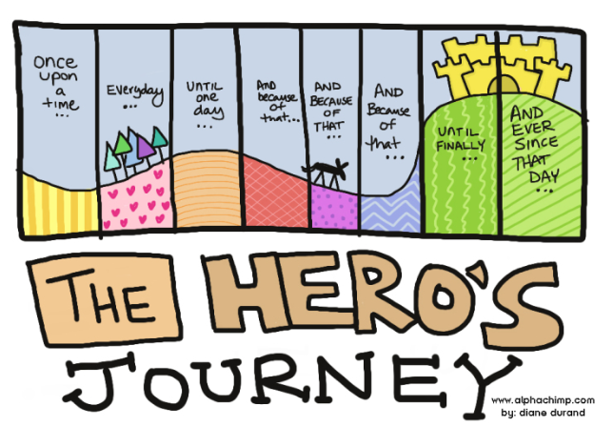
- No “I” or “You”
- No Contractions: can’t = can not
- No “This quote…”
- No Good, bad, a lot, big, little
- NTSSWTSW
- Limit “to be” verbs
(am, is, are, was, were)
Name _________________________
Period _______
Introduction Paragraph 1 Due:

Comparative Essay

- Attention-grabber (not a question)

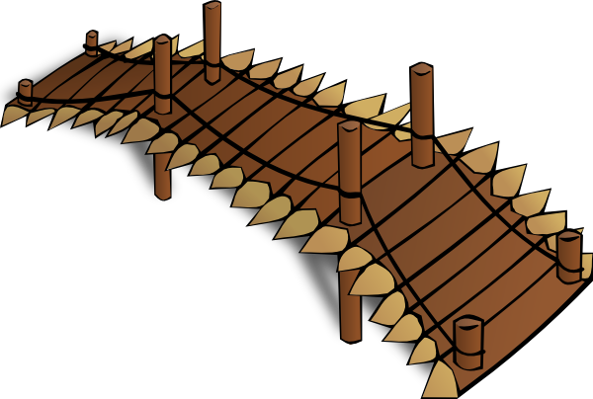
- Bridge (2-3 sentences that link the attention-grabber to the thesis statement)

C. Thesis: The monomyth permeates through the literature of all ages, from Odysseus’ Journey in Homer’s Epic Poem, The Odyssey, to that of the modern day super hero ________________________ in ___________________________, the basic pattern of the monomyth is evident in many epic stories written over the course of history.
How to do Parenthetical Documentation
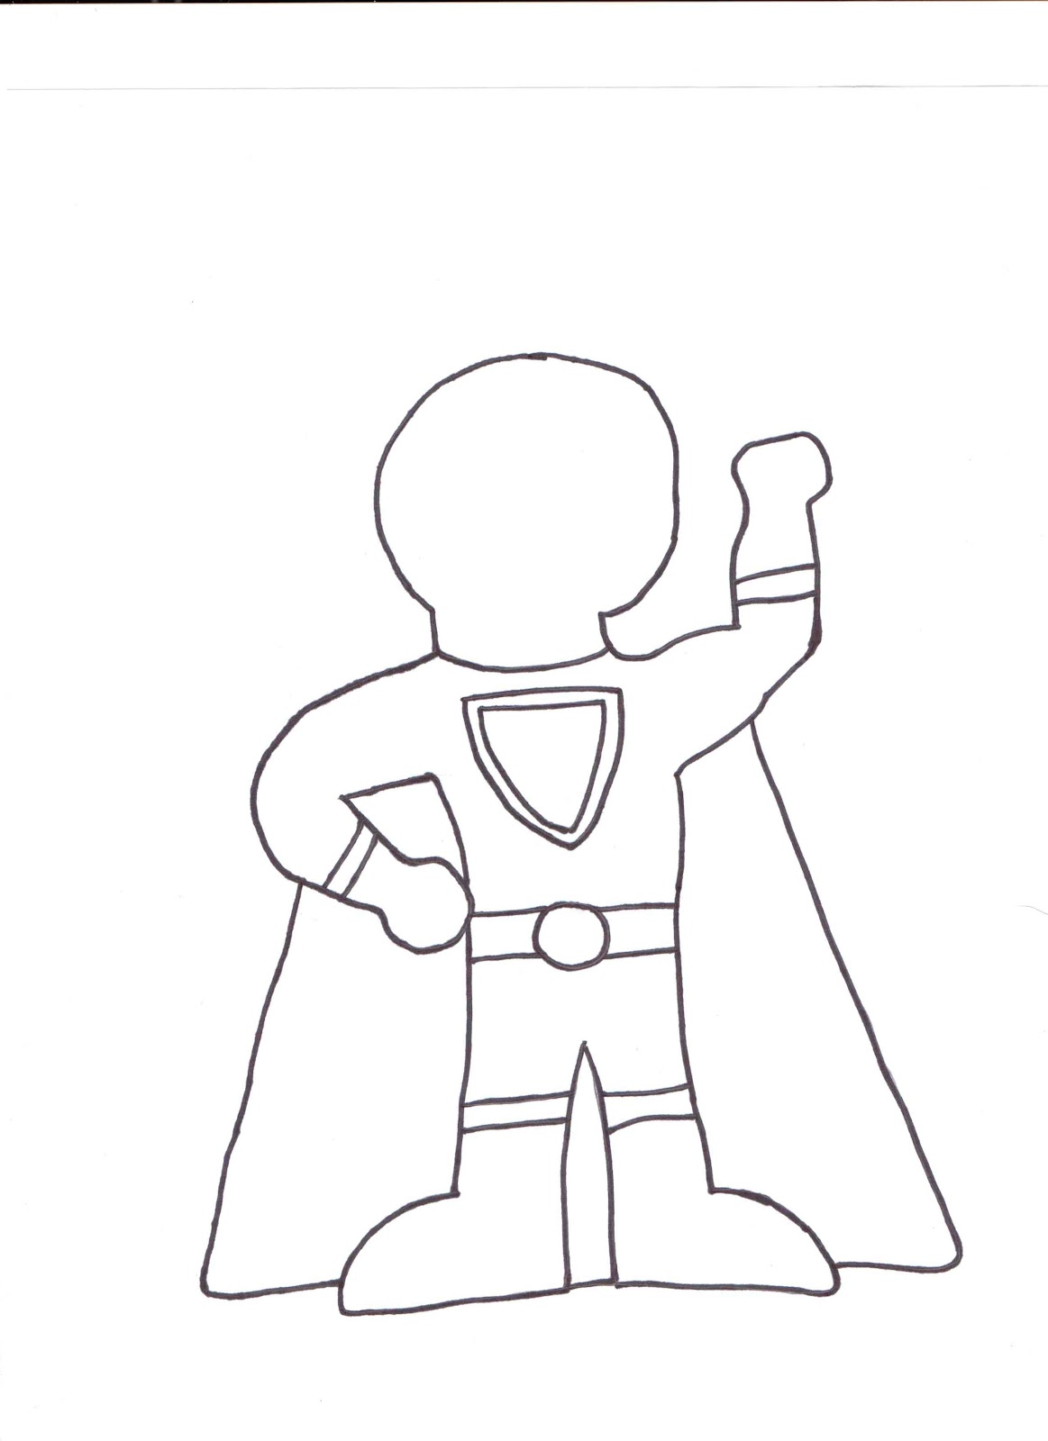
Work found in an anthology or edited collection: (Such as the Language Arts textbook)
For an essay, short story, or other document included in an anthology or edited collection, use the name of the author of the work, not the editor of the anthology or collection, but use the page numbers from the anthology or collection.
When Homer's Odysseus comes to the hall of Circe, he finds his men "mild / in her soft spell, fed on her drug of evil" (1149).
Odysseus asks Polphemus, "O Cyclops! Would you feast on my companions?” (Homer 1105).

acknowledges | comments | describes | maintains | reports
adds | compares | disputes | notes | responds
admits | concedes | emphasizes | observes | shows
agrees | confirms | endorses | points out | states
argues | contends | illustrates | reasons | suggests
asserts | declares | implies | refutes | summarizes
claims | denies | insists | rejects | writes

Quotetation
Signal Verbs to help integrate quotes
Transition Word

- ____________, in Homer’s Epic Poem The Odyssey, the character Odysseus closely follows the pattern of the Hero’s Journey.
Topic Sentence
Set up Quote
Intergration Quote P Documentation
Explanation of Quote
Concluding Sentence

Body Paragraph 1 Due:
Transition Word
__________________,

DO NOT HAVE TO USE EXAMPLE ONLY
B. First, after defeating the Trojans at Troy, Odysseus answers the call to adventure by setting sail to Ithaca.
Transition Word
B.____________

C. Integrated quote from the beginning of the poem with parenthetical documentation.
Integration or signal phrase

(Homer ____).

_____________________,

Quote
Parenthetical Documentation

D. Explanation of what is happening in this part of the poem and how your quote proves or illustrates that part of the journey.

DO NOT HAVE TO USE EXAMPLE ONLY

E. Next, Odysseus is put through multiple tests and trials on his quest to reach Ithaca
E.____________

Transition Word

F. Integrated quote from the beginning of the poem with parenthetical documentation.
Integration or signal phrase
Topic Sentence
Set up Quote
Intergration Quote P Documentation
Explanation of Quote
Concluding Sentence

(Homer ____).

___________________,

Parenthetical Documentation
Quote

G. Explanation of what is happening in this part of the poem and how your quote proves or illustrates that part of the journey.

DO NOT HAVE TO USE EXAMPLE ONLY
H. Finally, Odysseus receives the Hero’s ultimate reward when he returns home, is reunited with his wife and son, and regains his rightful place as king of Ithica.
Transition Word
_________,

Integration or signal phrase
I. Integrated quote from the beginning of the poem with parenthetical documentation.

(Homer ____).

___________________,

Quote
Parenthetical Documentation

J. Explanation of what is happening in this part of the poem and how your quote proves or illustrates that part of the journey.

Topic Sentence
Set up Quote
Intergration Quote P Documentation
Explanation of Quote
Concluding Sentence

K. Concluding Sentence

Transition Word
________________, _________________________________________________

Body Paragraph 2 Due:

- ______________________it is possible to find similarities between Homer's "The Odyssey", written almost 3,000 years ago and ________________much more recent hero __________________________________.
Transition Word
________________,

YOU DO NOT HAVE TO USE EXAMPLE ONLY

B.____________, (your hero’s name)______________________, answers the call to adventure when/by________________________________________.
____________,

Transition Word

C. Example from the movie
In the movie____________________, the hero,_____________________________

Words to Help Compare
By the same token, conversely, in comparison, likewise, similarly, comparatively, coupled with, correspondingly, identically, likewise, similar, moreover, together with, also, again, as well as, likewise, comparable, complementary, coincide, in agreement, corresponding, matching, much the same, related, resembling, identical, resembling

- Explanation of what is happening in this part of the movie how it relates to Odysseus’ journey
Paralleling Odysseus ___________________________________________________
DO NOT HAVE TO USE THIS FORMAT
EXAMPLE ONLY

E.(Transition Word)______, (name)_______________ is put through multiple tests and trials on his/her quest to _____________________
Transition Word
_____________,

F. Example from the movie

DO NOT HAVE TO USE THIS FORMAT
EXAMPLE ONLY

G.Explanation of what is happening in this part of the movie how it relates to Odysseus’ journey
Transition Word
Equivalent to Odysseus’ ___________ (name)_______________ also ____
______________________,

H. (Transition Word), (Name)______________receives the Hero’s ultimate reward when he/she _________________________________________________________.
________________,

Transition Word

- Example from the movie

J. Explanation of what is happening in this part of the movie how it relates to Odysseus’ journey
DO NOT HAVE TO USE THIS FORMAT
EXAMPLE ONLY

Much like Odysseus, ___________________________________________________________
Transition Words

K. Concluding Sentence In conclusion, The monomyth has proven itself to be a timeless tool used by authors across the ages.
Transition Word
in the first place
not only ... but also
as a matter of fact
in like manner
in addition
coupled with
in the same fashion / way
first, second, third
consequently
therefore
thereupon
forthwith
accordingly
henceforth
after all
in fact
in summary
in conclusion
in short
in brief
to summarize
on balance
altogether
overall
ordinarily
above all, chiefly, with attention to, especially, particularly, singularly
for example, for instance, for one thing, as an illustration, illustrated with, as an example, in this case
comparatively, coupled with, correspondingly, identically, likewise, similar, moreover, together with at first, first of all, to begin with, in the first place, at the same time, for now, for the time being, the next step, in time, in turn, later on, meanwhile, next, then, soon, the meantime, later, while, earlier, simultaneously, afterward, in conclusion, with this in mind after all, all in all, all things considered, briefly, by and large, in any case, in any event, in brief, in conclusion, on the whole, in short, in summary, in the final analysis, in the long run, on balance, to sum up, to summarize, finally also, again, as well as, besides, coupled with, furthermore, in addition, likewise, moreover, similarly

_________________,

Concluding Paragraph Due:

Transition Word
- Restatement of the thesis statement
__________________,

Reword the thesis

B. Summary of Body Paragraph 1
Transition Word

___________________,

C. Summary of Body Paragraph 2
Transition Word

___________________,

________________,

Transition Word
D. Reference back to Attention-Grabber
Do not use the quote, fact, statistic, or definition again. Be sure to references back to the attention grabber
-not just restate it.

