Perfect Mate: Student Form
In Act I Scene 2 of Romeo & Juliet, Lord Capulet, Juliet's father, and Paris, cousin to Prince Escalus who wants to marry Juliet, discuss the marriage. In many cultures marriages are arranged by parents with little or no input from the bride and groom. In this scene Capulet tells Paris:
My will to her consent is but a part.
And she agreed, within her scope of choice Lies my consent and fair according voice.
So, Lord Capulet at least is telling Juliet's suitor that she must also consent to the marriage. Of course, we found out that Juliet didn't want to marry Paris. She has fallen in love with the son of her family's arch-enemy, Lord Montegue.
Have you ever dated or even expressed an interest in a guy or girl that your parents disapproved of? If so, you should have some empathy for what Romeo and Juliet are going through in this play.
If you had to list the traits (physical, personality, etc.) of your perfect mate, what would they be? Try to be as specific as you can be.

Now, get behind the Eight Ball and try to figure out what traits your parent(s) or guardian would list if they were choosing the perfect mate for you. Again, try to be specific.

REMEMBER! Don't let your parent(s) or guardian see your list until they have done theirs on the other side.
Please have both sides of this survey completed and with you in class.
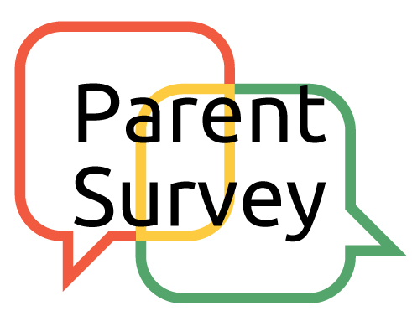
Perfect Mate: Parent(s) or Guardian Form
Dear Parent or guardian:
We are reading Shakespeare's "Romeo and Juliet" in English class and I would appreciate your taking the time to complete this survey.
As you may remember from your own high school English class, the play centers on two young people who fall in love. Their parents, however, are enemies and make the relationship impossible for Romeo and Juliet. On the other side of this sheet I have asked the students to list traits THEY would want in a "perfect mate." Now, I'm going to ask you to do the same, without having looked at their lists first. Naturally, you're welcome to read what they said after you've answered the questions. I encourage you to talk with your child about what he/she is learning about Romeo and Juliet's predicament and how it compares to parent/teen relationships today.
Thanks for your help in completing this project and please check the class website at www.cafedudek.com for all the assignments, calendars, extra tutorials, and helpful Act summaries.
Mrs. Dudek edudek@gatewayk12.org
What traits (physical, personality, etc.) would you think your son or daughter would look for if searching for the perfect mate for himself or herself?

Now, what traits would you consider most important if you were choosing the perfect mate for your son or daughter?

Parent Signature: _______________________________________

