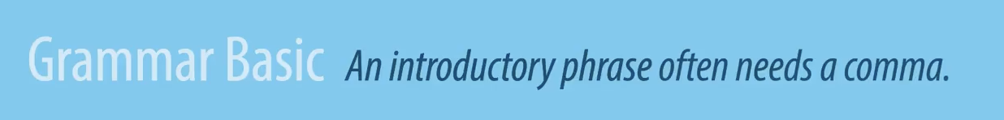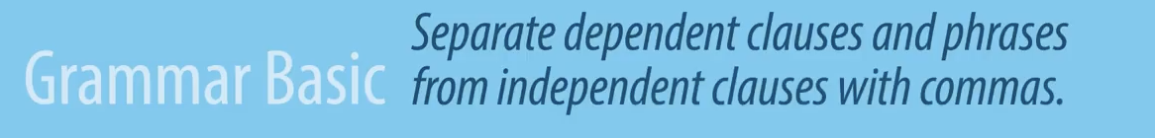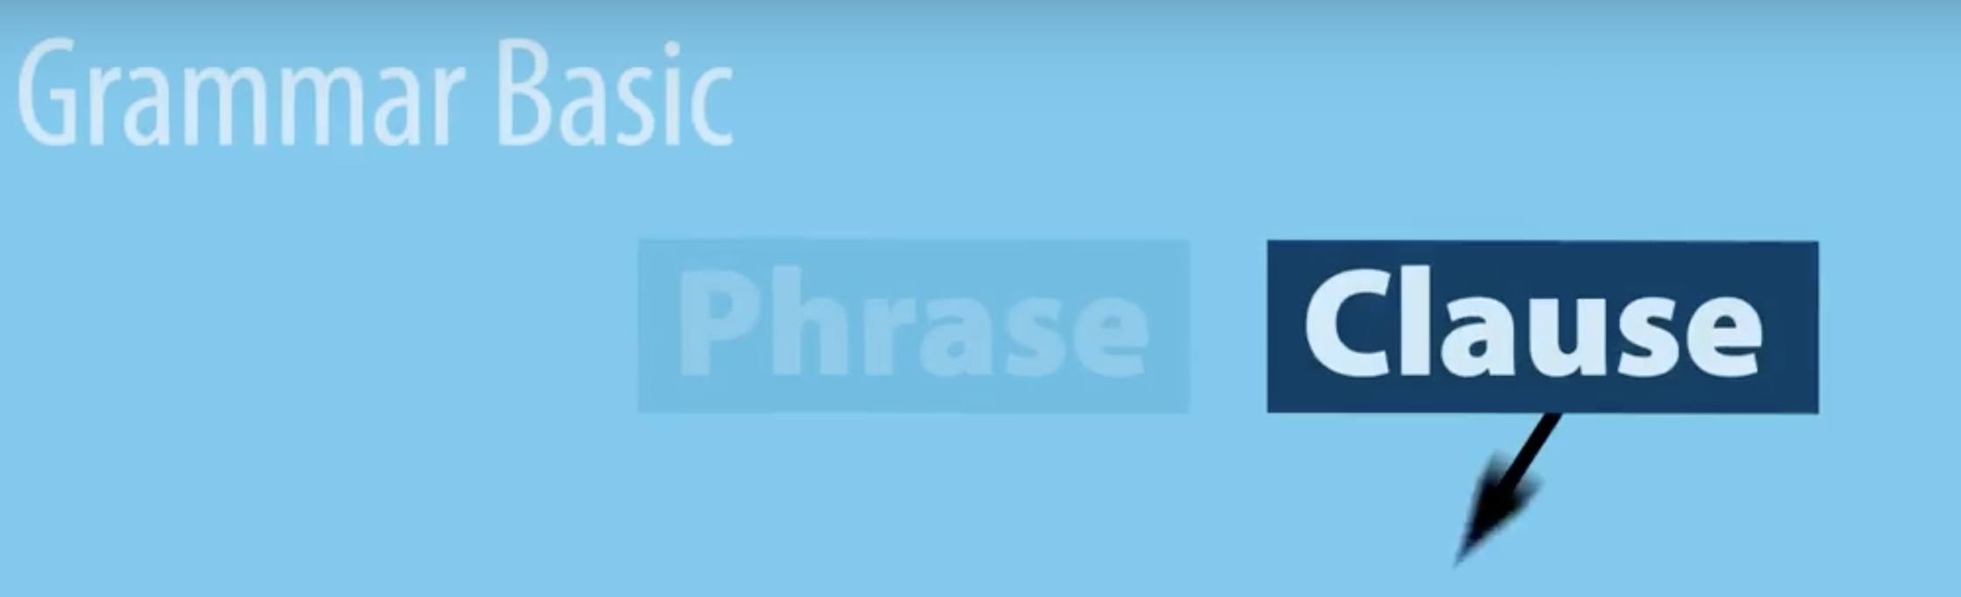

https://youtu.be/_UcvlRnT6LM

Makes it ___________________________

Dependent Clause is

Independent Clause is

Once you find a clause you have to ask yourself the question is it a ______________________________ or a ______________________________

Clause