Name:_________________________
- Exposition: the part that _____________________, introduces characters, and provides _____________action.

- Antecedent action: is what happens ___________ the story, poem or play began or what happens ______________.

- ___________________: Moments of high _____________. These moments can cause characters to respond and the plot to progress.

- __________________________: The moment of _____________________ at which the outcome will be decided. It is a critical _______________ in the story such as when a character makes a critical decision.

- Falling Action: The ___________________ are ______________. The pieces all begin to fall into place.

- _____________________:The final outcome.
- Sometimes plots can have more than _________________. He suggests that stories can have multiple ________________.

- Suspense: The pleasurable _________________ we feel that heightens our attention to the story, resides in our wondering _____________________________________.

- Foreshadowing: An indication of _____________________. Often creating anticipation (suspense)

- _____________________: Some moment of _____________, discovery, or revelation by which a character’s life, or view of life, is greatly altered.

- Characters:
- _____________________ : The main character
- This is not always a _________________ person. They can have good and bad characteristics, or they can have all negative characteristics.

- ________________________: The character who opposes the protagonist.

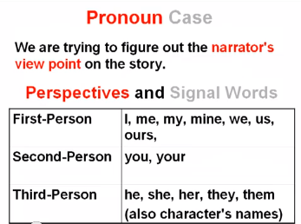
Plot Elements: Point of View (Part 3)
Name:_________________________

Dialogue and Narration
Dialogue =___________________________

Narration= __________________________
__________________ separates narration
from dialogue.

First Person | Uses “I” or “we”
Second Person | Does the narrator tell the thoughts and feelings of the characters?  Uses “you” or “your”
Third Person | Third-Person  Narrator usually isn’t involved. Tells other’s stories.  “Lots of “He,” “She,” & character names. Three Types of Third- Narration
Third Person Omniscient | Narrator is all knowing
Third Person Limited
Third Person objective | Only characters ________________ and actions are narrated
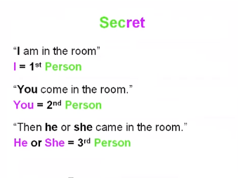
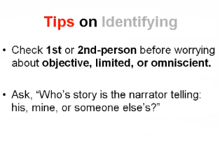
Plot Elements: Foreshadowing
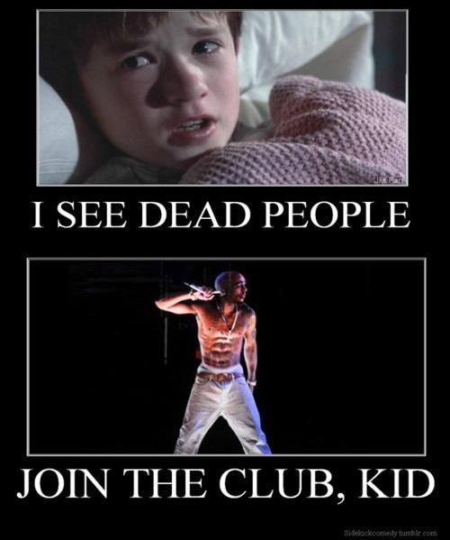
Concrete Foreshadowing
Sometimes foreshadowing is employed by taking concrete objects and things and using them to signal various ideas to the reader. Examples of concrete foreshadowing can include objects, people, colors, places, or events, or any combination thereof. Concrete foreshadowing means using something that characters can physically see, though the meaning behind the object may not be blatantly obvious.
For instance, in The Sixth Sense, the audience was never allowed to see Bruce Willis' character without his jacket on. He was always wearing a suit coat, a winter coat, or a bathrobe. Watching it for the first time, you may not even have perceived or understood this small detail, but it was there in plain view.
Abstract Foreshadowing
In concrete foreshadowing, the author or director uses tangible, visible objects and places to convey the hints he wishes you to receive. In abstract foreshadowing, however, it is themes, words, nuances, sounds, and other intangible clues. For example, an author might mention a particular thought that a character is having, or the character will hear a specific noise. These aren't objects, but rather things that the reader can sense.
Prominent Foreshadowing
The Masters of Suspense (Stephen King, Dean Koontz, Richard North Patterson, etc.) use this mode of foreshadowing brilliantly in their work. Prominent foreshadowing involves telling your reader what is going to happen. Sometimes, it is used in a prologue or preface, and sometimes it is used sporadically throughout the work.
In Dean Koontz's From The Corner Of His Eye, he tells the reader in the first chapter exactly what will happen to the main character.
Evocative Foreshadowing
This is the equivalent of handing out snacks at a party, but waiting until later to serve the main course. If you want to give your reader a taste of what will happen in the chapters to come, but you don't want to be very specific about the events, then evocative foreshadowing is the way to go.
One of the most famous lines in literature using evocative foreshadowing is "little did I know…" If you've read any of the older fiction from the fifties and sixties, authors often used this phrase to introduce the plot. For example, Little did I know that in one week, I would wish I had never opened that package from Aunt Lucille.

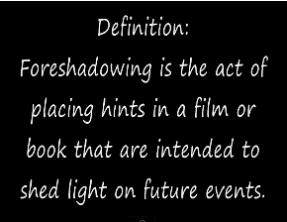
There is something to be said for the art of surprise. When we read a novel or watch a movie, it's the shocking denouement that sticks in our minds and urges to come back for a second helping. In the world of entertainment, we don't mind being fooled, as long as we aren't disappointed in the ending. But are there ways to make the craft of surprise even more satisfying?
Remember the movie The Sixth Sense? The little boy could see dead people, and he was able to communicate with ghosts, but we didn't find out the real kicker until the very end. At that point, the directors took you through various scenes from the throughout the moment, showing you the hints that would have led up to the conclusion. You didn't figure it out until the last possible moment, and you had no idea what the clincher was, but the clues had been laid out for you all through the movie.
That is the bread and butter of foreshadowing. It can be used in prose just as effectively as in the movies, and sometimes it is even more thrilling when read than when seen. Foreshadowing means hinting to the reader about what is to come without purposefully spoiling the conclusion.
There are four different types of foreshadowing,, all of which have separate purposes. Using them effectively can mean the difference between a harrowing, exciting tale, and a flat, boring story.

Concrete
Abstract
Prominent
Evocative

Plot Elements: Types of Conflicts
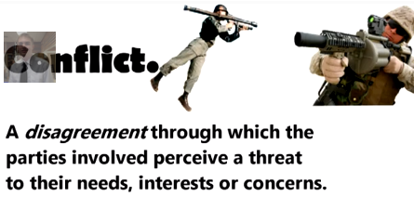
A conflict is more than a disagreement it is a situation

Person vs
Person vs
Person vs
Person vs
Person vs
Person vs
Person vs

