https://www.poemuseum.org/poes-biography

- Poe was a master of the _________________________________

- He wrote _______________________, ___________________________, ______________________ and more.

- Often called the father of the _________________________________________.

- But much of what we know about Poe is wrong, the product of a biography written by one of his enemies named _________________________________in an attempt to ___________________________Poe. The actual effect was the _____________________.

- He was born Jan 19 ______________ in __________________________.

- His mom and dad both died before he was ___________years old.

- He started writing poetry when he was about _______________________.

- In 1826 Poe left Richmond to attend the University of Virginia. Describe his experience at college

- How long was Poe at West Point? _______
What happened? ______________________

- When he visited the home of his fiancée, Elmira Royster, only to discover ___________________________________________

- Talk about dysfunctional… Broke and alone, Poe turned to Baltimore—his late father’s home—and called upon relatives in the city.
- List 2 facts about his family that are reality TV worthy.
- 1)
- 2)

- He married his ______ year old ______________ when he was ______________ years old.

- She died when she was just _____________________.

- During his lifetime, he ___________________ made a living from his writing.

- People assumed he dabbled in _________________ most likely believed to be __________________________.

- In 1841 he invented what is called ____________________________ when he wrote "The Murders in the Rue Morgue."

- He wrote “The Raven” in _____________________ and it was his huge breakthrough.

- He returned to Richmond in the summer of ____________ and reconnected with his first fiancée, Elmira Royster Shelton who was now a widow.

- At 40 years of age, he died in ______________________ it is so strange because

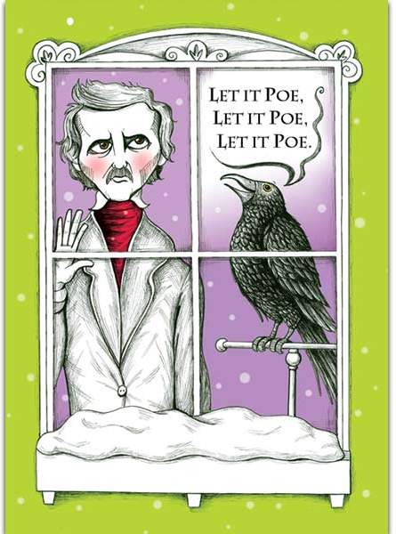
- His legacy can still be found in today’s stories in

