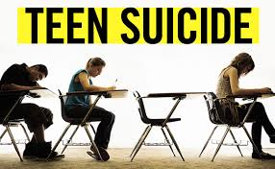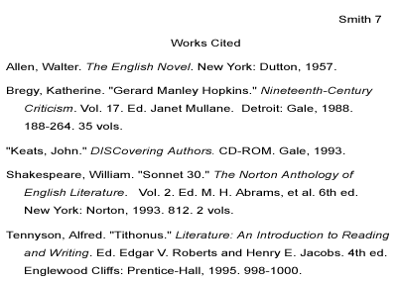 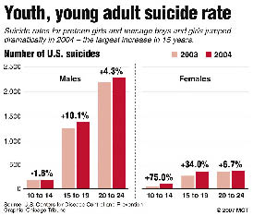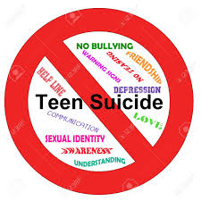

## Works Cited

## What you can do to help.

* Solution 1
* Solution 2

Love and Hurt

[Street Address]  
[City], [State][Postal Code]

r7j@gmail.com

R&J Hotline

By

______________________

# Book Quote

**Integer eu nunc.** Suspendisse nonummy mauris eu justo. Nunc vehicula dui a quam. Aenean rutrum. Cras varius purus sed quam. Vivamus nisi ligula, lobortis nec, venenatis id, molestie nec, diam. Etiam condimentum ultrices libero. Duis consectetuer ligula ut velit tincidunt molestie. Duis libero sem, convallis eget, luctus ac, volutpat vel, nulla. Mauris vulputate neque et nulla. Nullam vulputate volutpat turpis.

According to *The New York Times* 35% of teens think about suicide at least one time in high school (Smith 2).

Fact 2

Fact 3

### 3 quotes/facts bout Teens suicide