Scary Story Creative Writing Assignment
Name_______________________

The famous monster story, Frankenstein, was written by Mary Shelley after she entered a friendly contest with her husband and their mutual friend to see who could write the scariest ghost story. Her short story eventually became the novel that has thrilled readers for centuries.
As a class, we will be conducting our own friendly competition. For this writing assignment, everyone will write a short scary story. While reading the short scary stories, we will focus on how authors think about audience in order to fulfill a purpose, to scare, and to entertain.
As a class, we will read, edit, and judge each other’s stories to determine who wrote the scariest story. Your grade will be determined by the effect your story has your audience (in this case, how your classmates rate your story). Once completed, all of our stories will also be used to construct an online class anthology so we can scare the other sections and even future students!
Horror stories can take a variety of forms ghost story, monster story, psychological thriller, zombie apocalypse… so feel free to get creative! Just be sure to keep your story rated PG13.
Task: In this creative writing assignment, your task is to write a 2 ½-3½ page story that is suspenseful and creates a creepy or ominous mood. The goal is to create a story that is creative, not predictable, scary or creepy but not distasteful Have fun with this! Make it scary, creepy, and entertaining to read! You will be asked to provide some analysis of your own story once your rough draft is completed.

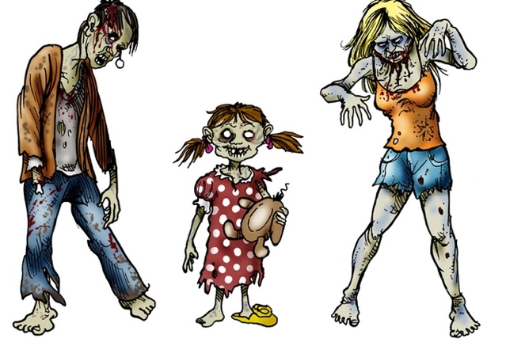
Due Dates:
Prewrite: _________
Plot Outline: _________
Rough Draft _____________
Scary Story Analysis: __________
Peer/teacher Edit:___________

Final Draft Due on Turnitin.com: _______________

You need to bring a hard copy to class and be prepared to present the day your paper is due.

Requirements: Please use Elements handout and your notes to help you…
- MLA: Story must be written in Times New Roman, 12 pt font, heading must be at top right hand corner (Name, date, period, assignment name), double-spaced, and you must give your story a creative title which should be centered and also be in Times New Roman 12 pt font (no bold or underline or lg font).
- Your story must have a vivid setting which adds to the story.
- Your story must have 5 examples of dialogue, even if it is only one character talking to himself/herself.
- You must use a minimum of three modes of characterization to describe your main character(s).
- Your story must clearly contain an exposition, rising action, climax, falling action, and resolution
- include at least five examples of strong imagery in your story.
- include at least three different examples of literary devices (not including imagery) in your story. Include elements for effect where needed: flashback, irony, symbolism
- Must have a plot that begins immediately with a major conflict that is underway by the end of the first page, if not sooner.
- Must have a clear resolution that is developed (not one sentence or a total cliffhanger).
- You must use foreshadow to build suspense.
- Your story must be 2 ½ -3 ½ pages!
- This needs to be your own idea and your own words, please do not use the internet to rip off an idea or a source. Use your own brain. Please follow all directions (Make sure you use the above five items.)

Other helpful hints:
- Use active verbs (no “to be”)
- Use figurative devices (simile, metaphor, etc) to paint a vivid picture of the setting and characters
- Dialogue should sound like actual conversation (create a voice for your character - you can use slang)
- Don’t clutter your piece with unnecessary adjectives and adverbs, and do try to vary your word choice
- Remain in the same point of view and same verb tense throughout the entire story
- Don’t save this for the last minute and be sure to use the back of this paper to brainstorm

Scary Story Prewriting

1. Who is your audience for this story?
2. What is the purpose for writing this story?
3. Choose an interesting “what if.” For example...what if you were trapped in a movie theatre?
4. Think about all of the scary things that could happen in that situation. Then, think about all the ways a person could get out of that terrifying situation.
5. Who is the main character? Is it you or a fictional person?
6. What other characters might be involved?
6. Choose a scary setting. Decide where and when your story takes place.
7. How did the main character (and maybe the others) end up in the scary situation?
8. Is there a bad guy or villain? If so, describe this character and how he or she will provoke fear in the story.
9. If there’s no bad guy or villain, what provokes the fear in the story? How does it provoke fear? 10. Develop the plot by using the following questions.
 What beginning/introductory info will be necessary (i.e., exposition)?
 What problems will the main character face (i.e., rising action)?
 What will be the turning point in the story (i.e., climax)? (The climax should be a surprise.)
 What will happen after the climax (i.e., falling action)?
 How will the story end (i.e., resolution)?

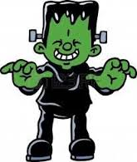
Scary Story Analysis

- Title ________________________________________________________

- Protagonist ______________________________________________________

- Antagonist ______________________________________________________

- Minor characters ___________________________________________________

- Which point of view are you using? If it is a character in the story, which one?

- How are you characterizing each of your characters?
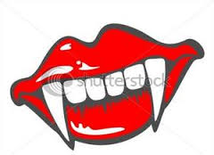
- What are some conflicts your main character face? How are they resolved?

- Setting
  - Time:
  - Place:
  - Description of overall setting:

- Towards which event is your foreshadow hinting? If you did not use foreshadow, add it in now.

- What is the purpose of your dialogue? Are you showing action?

- In which way did you use figurative language? Are you using imagery (showing details) throughout? How?

- Summary of plot:

Scary Story Plot Outline

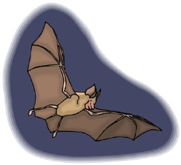
Climax

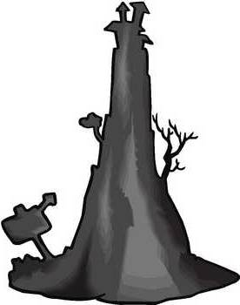
Falling Action

Rising Action

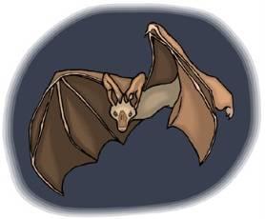
Is there an underlying message (theme)?

Exposition: (beginning)
Resolution:
Think about the following criteria when constructing your story and reading the stories created by your peers:
Characteristics of a scary horror story | Characteristics of a not-so-scary story
- ● Shows a reader why they should be scared; uses sensory details to paint a picture in reader’s mind.  - ● Protagonist(s) are r elatable to reader; reader is able to place themselves in the shoes of the protagonist(s).  - ● Thes etting setsorenhancesthescarymoodofthestoryfor the reader  - ● Builds s uspense for reader; delays the action (i.e. horror elements) until the right moment.  - ● In summary, a scary horror story considers the effect of its elements (story, setting, character, details, etc) on a reader. | - ● Tells a reader why they should be scared; could use more sensory details to paint a picture in reader’s mind.  - ● Protagonist(s) could be more r elatable to reader; reader has difficulty imagining themselves in the shoes of the protagonist(s).  - ● The s etting c ould enhance or set the scary mood of the story more for the reader  - ● Could build more s uspense for reader; j umps quickly into the action.  - ● In summary, a notsoscary horror story could consider the effect of its elements  (story, setting, character, details, etc) on a reader more.

*With that said*...
A good horror story is not afraid to break some of these conventions in order to accomplish other goals. While many horror stories utilize creepy settings such as a cabin in the woods, a graveyard, or an abandoned factory, a horror story could focus on a safe and normal setting and make it scary by making it unsafe.
Use the above table and the following questions when judging your classmates’ scary stories. Note: It’s very important that you include detailed comments as I will use them to help determine the final placements of the stories. Use the back of this sheet if you need more space.
- How did the sensory details enhance your reading of the story?

- How easy did you find it to place yourselves in the main character(s) shoes?

- How did the setting enhance your reading of the story?

- How well did the author build tension and suspense?

- How scary did you find the story? (Rate the story on a scale of 1-10 Skulls)

AUTHOR’S NAME: ________________________________________
Scary Story Rubric
 | EXCELLENT 12 | GOOD 9 | FAIR 6 | POOR 3
Proof of Writing Process | All elements 6 included: revised 1st draft, completed revision checklist, revised/edited 2nd draft, 2 completed peer checklists, final draft | At least 5/6 elements included | 3-4/6 elements included | Only 1-2 elements included
Required Vocabulary Terms | At least five (5) challenging vocabulary terms that are underlined twice | 3-4 challenging vocabulary terms that are underlined twice | 1-2 challenging vocabulary terms that are underlined twice (or not underlined) | 0 challenging vocabulary terms that are underlined twice (or not underlined) (or words underlined not challenging)
Required Figurative Language | At least ten (10) examples of figurative language that are underlined once | 7-9 examples of figurative language that are underlined once | 4-6 examples of figurative language that are underlined once (or not underlined) | 3 or less examples of figurative language that are underlined once (or not underlined)
Creativity | Story idea is fresh and imaginative; contains many creative details and descriptions; setting vivid and well-described | Story idea somewhat interesting; contains some creative details and/or descriptions; setting described well enough to imagine | Story plot vague; contains few creative details and/or descriptions; setting somewhat vague | Story unoriginal; contains very little (if any) creative details or descriptions; setting overly vague or not described
Plot Development & Organization | Plot is well-developed and consistent; conflict well- established; exciting climax; clear resolution; beginning, middle, end tie together | Plot makes sense; conflict present; climax present; resolution present; beginning, middle, end mostly tie together | Plot somewhat developed, but missing elements (climax, resolution) and may be hard to follow; beginning, middle, end not tied together well | Plot poorly developed and hard to follow; missing elements; beginning, middle, end not tied together
Characters | Characters are interesting, well- developed through dialogue, actions, thoughts | Some characters well- developed through dialogue, actions, thoughts | Characters described, but little to no dialogue, action, or thoughts | Characters not fully described, few details given, no dialogue, action, thoughts
Mechanics | 1-0 errors in grammar, spelling, usage, capitalization, or punctuation | 2-5 errors in grammar, spelling, usage, capitalization, or punctuation | 6-9 errors in grammar, spelling, usage, capitalization, or punctuation | 10 or more errors in grammar, spelling, usage, capitalization, or punctuation
Format | All format requirements fulfilled on final draft:  - - minimum 2 pages  - - double spaced  - - font legible & normal size  - - complete heading (top left corner)  - - creative title  - - paragraphs/dialogue  - indented

