https://youtu.be/VfOR1XCMf7A
Name ______________________________

The 1920s are stereotypically known as the _________________________

is defined as

Productivity grew due largely due to

What lead up to the increase in leisure time?

Credit/______________ and ____________________ became new concepts

“High Culture” also flourished this was the age of the __________________________________ of American Writers.

The capital of “Black America” was _____________________________

The spirit of The Harlem Renaissance can be summed up as

Women tried to liberate themselves and express autonomy by

An estimated _____________% of Americans lived in poverty.

Jobs like ___________________________________ declined while new jobs such as ___________________________ and ____________________.

For the first time in American history, the number of _________________________ declined in the 1920’s.

Also, a resurge in the KKK came about and by the mid 20s the Klan had over ___________________ members.

The Scopes Trial stood as a symbol for

What are traditional American values?

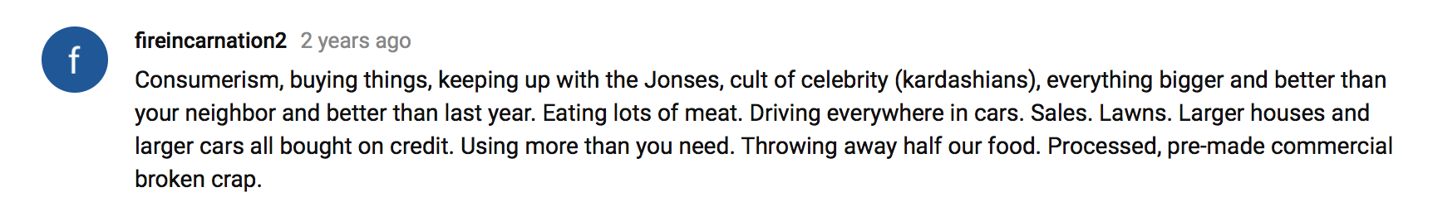
What is your definition of the American dream? Describe some examples of people you know, have heard about, or have read about that have dreamed an American dream.

According to this article, what is the classic definition of the American dream? Do you think that this dream (as it is classically defined) often comes true? Why or why not?

Why do you think more people believe in the American dream today than they did four years ago, when our economic outlook was much brighter?

Describe the shift in the definition of the American dream over the past years?

What do you think accounts for this change?

Which definitions of the American dream resonate most with you? Why?

Why do you think Barry Glassner believes that it would be difficult to find a different country where so many people believe in possibilities even in dire circumstances?

Do you agree with him? Why or why not?

