**Author's Purpose: Definition & Examples**

Name _____________

Period _____

Many different types of writing exist in the world, ranging from classic Shakespearean plays to politicians' speeches to the screenplay treatments that inspired this summer's biggest blockbuster hits. These works may vary in tone, genre and type, but as pieces of writing, they should have one thing in common: ____________________.

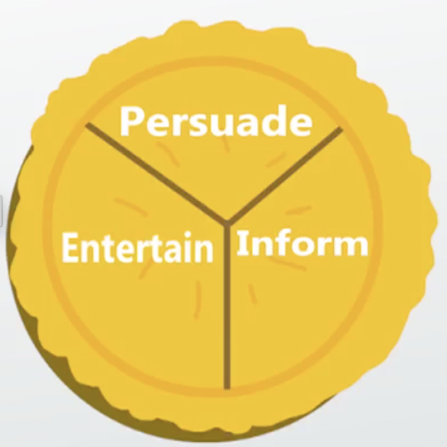

**PIE**, which stands for __________________, ________________, and ________________.

**To persuade** is the first main type of author's purpose. Text written to persuade means the author's goal is to ____________________ the _______________to agree with the ______________.

The second main type of author's purpose is **to inform**. In this format, the author's goal is to ___________________the reader about real-world topics and provide ______________ on those topics. However, in contrast to pieces written to persuade, these facts are ________ used to support a specific opinion. The facts are presented in order to _____________________________.

The final main category of author's purpose is **to entertain**. This contains almost all examples of what you think of when you hear the word 'literature.' Authors who write to entertain have the goal of _________________________ or describing real or imaginary characters, places and events. This includes all pieces of ________________, which is literature that is _________ real.

Some _______________________ works can fall under multiple categories. For example, ________________________ and ____________________ are based on real people and the events that really happened in their lives, so you might assume they are examples of pieces written to inform. However, some people are truly entertained hearing these true stories. Thus, autobiographies and biographies can fall under both to _____________ and ______________.

* Knowing the **author's purpose** behind writing is very important. It can change the format or structure of the piece, and even the words the author uses.
* It is important to note that there can be other subcategories of author's purpose. For example, to express, to surprise, to scare, to describe, etc., but all those can fall into one of the three major categories. As a reader, it's very important to be able to identify the author's purpose in order to fully understand that piece of writing.

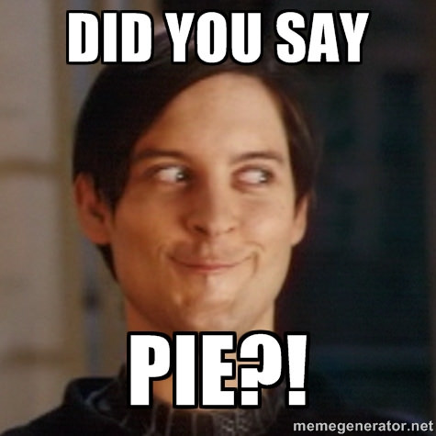

1. Read this description and decide the author's purpose.

A story about a family trying to stick together and survive through the Great Depression in the Midwest in the 1930s.

* to persuade
* to entertain
* to inform
* to amuse

### 

1. Read this description and decide the author's purpose.
2. A section in a history book describing the conditions and causes of the Great Depression in the Midwest in the 1930s

* to inform
* to entertain
* to persuade
* to amuse

### **The acronym for the three main types of author's purpose is**

* IPE
* AYE
* DIE
* PIE

1. Read the description and decide the author's purpose.

An article that argues an IPOD music player is better than a ZUNE.

* to amuse
* to inform
* to persuade
* to entertain

### **What is author's purpose?**

* the reason the author likes to write
* the reason the author writes a specific piece
* the reason the reader reads a specific piece
* anything the author wants