* Stories, novels, plays, and poems all have **___________________**, ideas about life that the author is trying to express. Let's start figuring out themes by looking at some stories that you've grown up reading.



Name _______________________

Period _______

* **________________** are short stories, usually about talking animals, that teach a ______________. Since fables teach a lesson, you know they have a theme; after all, themes are really just _______________________________.

The theme in *The Lion and the Mouse* is:

* Slow and steady wins the race.
* A stitch in time saves nine.
* Be careful what you wish for; you just might get it.

Even little friends can be a big help.

* Don't count your chickens before they hatch.

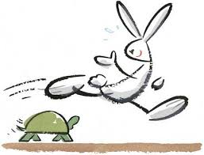

The theme of *The Tortoise and the Hare* is:

* Slow and steady wins the race.
* Even little friends can be a big help.
* A stitch in time saves nine.
* Don't count your chickens before they hatch.
* Be careful what you wish for, you just might get it.

### Longer pieces of literature can have several themes. One theme in The Diary of Anne Frank: A Play is:

The teen years are lonely years.

Technology is dehumanizing society.

Greed brings about mankind's downfall.

Be careful of what you wish for; you just might get it.

Crime does not pay.

### Which statement below BEST defines a theme used in literature?

Supporting details in an argument.

Where and when a story takes place.

The overall feeling of the work.

The ideas about life the author wants to express.

An idea that keeps coming up throughout the story.

**_______________________________** and **____________________**are the same thing - the big points that are being made about life.

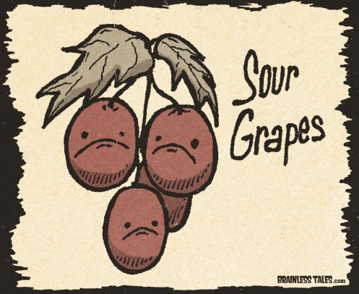

Consider the following fable:

A Fox one day spied a beautiful bunch of ripe grapes hanging from a vine trained along the branches of a tree. The grapes seemed ready to burst with juice, and the Fox's mouth watered as he gazed longingly at them.

The bunch hung from a high branch, and the Fox had to jump for it. The first time he jumped he missed it by a long way. So he walked off a short distance and took a running leap at it, only to fall short once more. Again and again, he tried but in vain.

Now he sat down and looked at the grapes in disgust.

*What a fool I am,* he said. *Here I am wearing myself out to get a bunch of sour grapes that are not worth gaping for.*

And off he walked very, very scornfully.

What is the theme of this fable?

* Work hard, and you'll achieve your goals.
* Some things aren't worth pursuing.
* It's easy to dislike what you can't get.
* Foxes don't like grapes.