Washington Irving An Autobiography
Author and editor, Washington Irving was born on April 3rd, 1783. His parents were William and Sarah Irving. They had eleven children, eight surviving into adulthood. Washington was born the same week the residents learned that the British ceased fire, ending the American Revolution. His mother named him after the American hero, George Washington, which Irving got to meet his namesake when he was six years old. The event was later recreated in a watercolor for Irving. Being an avid adventurer when he was
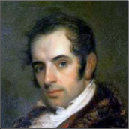
younger, Irving had little interest in school. He would always sneak out of school to visit the theater or go on a hike. Growing up and being placed with a friend due to a “yellow fever” breakout, Irving traveled near a town named Sleepy Hollow and often went through the Catskill Mountain region, prompting the settings of his two most famous works, “The Legend of Sleepy Hollow” and “Rip Van Winkle”.
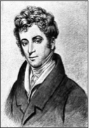
Painting of Irving meeting
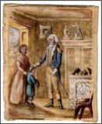
George Washington
In 1802, 19 year old Irving began writing letters to the New York Morning Chronicle under the name Jonathan Oldstyle.
After deciding a career in law,
the not-so-stellar student barely
passed the bar exam in 1806. In

1807, he created a magazine called
Salmagundi, where he wrote many
articles under many pseudonyms,
such as William Wizard and Lancelot
Landstaff. His magazine grew the reputation of today’s Mad Magazine.

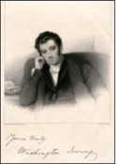
Like many authors, Irving experienced writer’s block on several occasions. While he was living in Europe, he became the victim of “literary bootlegging,” where other magazines would publish his work without his approval, which was common since there weren’t any copyright laws at the time. This caused Irving have his first four installments published in one volume, called The Sketch Book. After gaining popularity for publishing in both America and Great Brittan, writer’s block took hold of Irving again in 1822.

Breaking his writer’s block came while living in Germany in 1823 when Irving was pursuing a woman by the name of Emily Foster, who rejected his advances. There he wrote “The Devil and Tom Walker” under the name Geoffrey Crayon.
After 17 years abroad, Irving returned to America in 1832. After a short stint in politics and investing, he returned to writing as a source of additional income. He was often approached by younger authors for advice, such as Edgar Allan Poe for “The Fall of the House of Usher”. He died in 1859 from a heart attack, being known by many as America’s first great writer.
