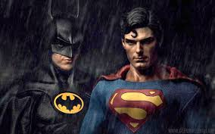
- What makes a hero?
Holding out for a Hero
Name______________________________ Period _______

- What is the difference between a celebrity and a hero?

- How do “super-heroes” differ from non-fiction heroes

- What is a hero?

- What role can myths and beliefs from the past have in today’s world?

- How does the definition of a hero change? and Why?

- How do we use stories to explain the world around us?

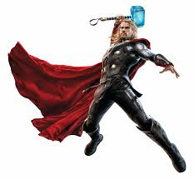
- Do you think the characters and stories of Batman and Spider-Man are more compelling than the stories of the other superheroes featured on film? If so, why?

- Superheroes almost always begin as ordinary humans who later acquire special powers. In their pre-superhero lives, these humans often are outcasts or “nerds.”

- Many have also experienced personal tragedies, challenges or setbacks.

- Superheroes are known for fighting evil, whether in the form of human criminals or super villains, so gaining superhero status allows tragic individuals to redeem themselves and/or avenge wrongs.

- Can you name some good examples of outcasts-turned-superheroes.

- Are the themes of redemption and vengeance also present in Greek myths?

- How are the motivations of superheroes similar to, or different from, those of Greek gods, goddesses and heroes?
- What author is most associated with the concept of the hero’s journey?
- According to the hero’s journey paradigm, the treasure you seek lies…
- What is another word for the “hero’s journey?”

