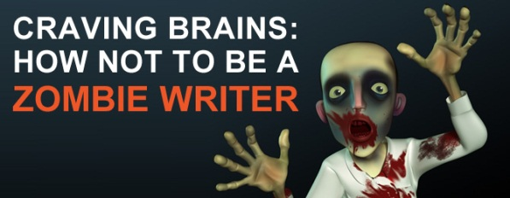
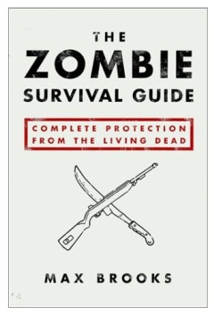
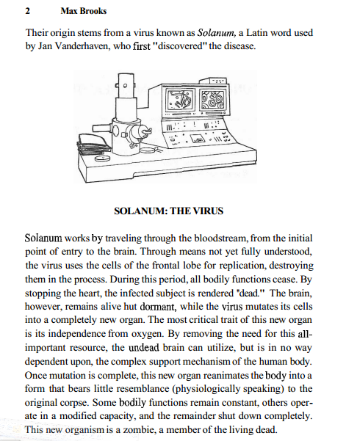
Help Max Brooks edit his paragraph
- Underline all “to be” verbs (is, are, was, were, be,been,).
- Check for NTSSWTSW and circle them.
- In the space below, rewrite the sentences that start with the same words to bring this paragraph back to life.

Find and Replace Lifeless “To Be” Verbs
Replace these lifeless words with interesting, action-packed verbs.
Land of the Living
Walking Dead Words

Help Max Brooks revise his sentences to eliminate “to be” verbs.

- Too often, the undead have been said to possess superhuman powers: unusual strength, lightning speed, telepathy, etc.

- Never forget that the body of the undead is, for all practical purposes, human.

- There is no way a zombie could fly unless the human it used to be could fly

- There is no question that zombies have excellent hearing. The basic range appears to be the same as that for humans.

- Historical research, coupled with laboratory and field observation, have shown that the walking dead have been known to attack even when all their sensory organs have been damaged or completely decomposed.

The Zombies Ate My Commas
Max Brooks needs your help replacing his missing commas in his paragraph below.
(Hint the zombies ate 15)

Cold hard figures have shown that when battling the living dead nothing has saved more victims than basic tight clothing and closely cropped hair. The simple fact is that ghouls attack by reaching out to grab their victims pulling them in then biting. Logic dictates that the less material a person offers up for grabs the better his or her chances will be. Baggy clothing complete with pockets straps or anything that might hang freely will be a convenient handle for grasping zombie claws. Anyone who has worked in factories or with some kind of heavy machinery will tell you the importance of never letting anything hang loose. Tight clothing obviously within comfort limits will help to eliminate this danger. Hair can be a similar hazard. Many times victims have been seized and even dragged by their hair to a gruesome end. Tying one's hair back before a conflict may work temporarily. However a short haircut one inch or shorter is ideal for hand-to-hand combat.
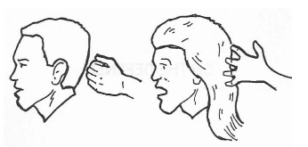

Paragraph Survival 101
The siege has commenced. Zombies swarm around your home, incessantly attacking but unable to enter. At this point, your worries are far from over. Waiting out a siege does not mean sitting idle. Many tasks will have to be accomplished and repeated for survival in a confined space. Designate one comer of your backyard to serve as a latrine. Most survival manuals will explain the finer points of construction and disposal. If soil and rain permits dig a vegetable garden. This ready source of food should be consumed first saving the canned food for an emergency. Keep it as far away from the latrines as possible to avoid infection not by waste but by the residual effects that lime or bleach will have on the soil. For electricity always resort to the manual (bicycle-powered) generator. Not only is the gasoline model loud and potentially dangerous-its fuel is finite. Use it only in extreme circumstances such as a night attack when manual power is unfeasible or impossible to generate. Patrol the wall constantly and always be vigilant for an unlikely but possible infiltration.
Help Max Brooks edit his paragraph
- Underline all “to be” verbs
- In the space below, rewrite the sentences minus the lifeless “to be” verbs.

- Add transition words to the sentences (use at least 5).
- Replace the commas the zombies ate (hint: they ate 6).
- Check for NTSSWTSW and circle the first word of every sentence.

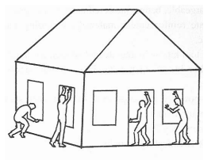

Zombies Only Use One Type of Sentence
Directions: Label each sentence as simple (S), compound (CD), complex (CX), or compound complex (CD-CX) in the space provided before each sentence.
- Maintain a low profile. ___________
- If you have a basement, do your cooking there, along with power generation and any equipment maintenance. ___________
- When you monitor the radio, something that should be done every day, use headphones.
- Keep blackout curtains on all windows, especially at night. ___________
- Remain entertained. ________________
- Despite the need for vigilance, recreation is a must. ______________
- Keep your earplugs handy, and use them often. _______________
- The constant, collective moan of the undead, a sound that will persist at all hours for as long as the siege continues, can be a deadly form of psychological warfare. _____________

Rewrite the following sentences into one smooth sentence. Remember, there may be many ways to combine each of these sentences.
Sentence Combining Tricks: 1. Sharing Important Words 2. Making Phrases 3. Join Sentences
- Stay out of sight. If you listen to the radio, do it at a minimum volume.

- Do not turn on the lights. Do not go near the windows. Make it seem the house has been abandoned.

- Make sure your escape route is planned. Have your gear packed to go. Be ready.

- Exercise daily. Use of the stationary bicycle will keep your body fit. Remain strong enough for any combat situation.
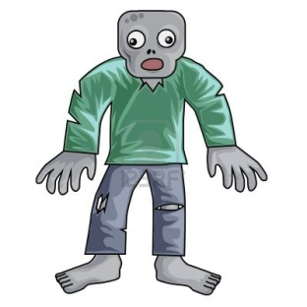

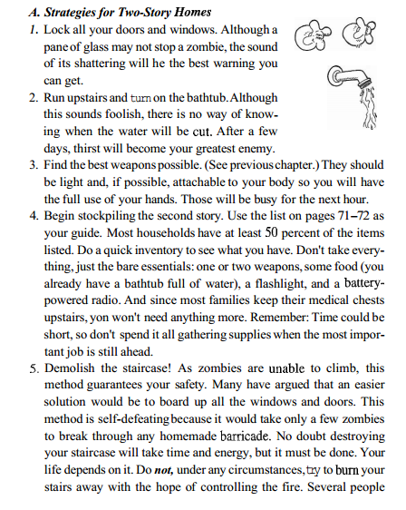
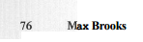
Monroeville overrun with zombies! Your English teacher, the cafeteria ladies and even your best friend have all joined the walking dead. Use your brain to flesh out a plan to avoid the Zombies, including where you would hide and the top 5 things you would bring with you to stay alive. Use at least 3 direct quotes from the passage and include parenthetical documentation.
Use the next page to construct your well-developed paragraph.
- Be sure to include a topic sentence.
- Use at least 3 direct quotes from the passage and include parenthetical documentation.
- Check for transition words within the paragraph.
- Make sure NTSSWTSW
- Avoid “to be” verbs.
- End with a concluding sentence.

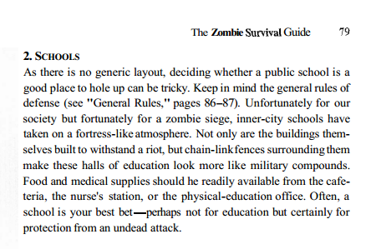

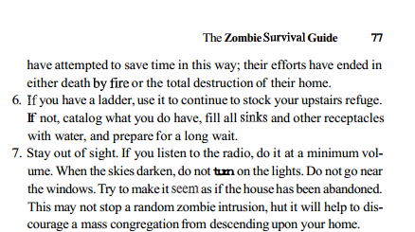

- Be sure to include a topic sentence.
- Use at least 3 direct quotes from the passage and include parenthetical documentation.
- Check for transition words within the paragraph.
- Make sure NTSSWTSW
- Avoid “to be” verbs.
- End with a concluding sentence.

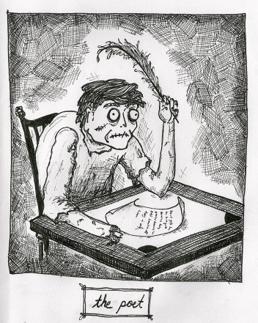

Key
Cold, hard figures have shown that when battling the living dead, nothing has saved more victims than basic, tight clothing and closely cropped hair. The simple fact is that ghouls attack by reaching out to grab their victims, pulling them in, then biting. Logic dictates that the less material a person offers up for grabs, the better his or her chances will be. Baggy clothing, complete with pockets, straps, or anything that might hang freely, will be a convenient handle for grasping zombie claws. Anyone who has worked in factories or with some kind of heavy machinery will tell you the importance of never letting anything hang loose. Tight clothing, obviously within comfort limits, will help to eliminate this danger. Hair can be a similar hazard. Many times, victims have been seized and even dragged by their hair to a gruesome end. Tying one's hair back before a conflict may work temporarily. However, a short haircut, one inch or shorter, is ideal for hand-to-hand combat.

The siege has commenced. Zombies swarm around your home, incessantly attacking but unable to enter. At this point, your worries are far from over. Waiting out a siege does not mean sitting idle. Many tasks will have to be accomplished and repeated for survival in a confined space. Designate one comer of your backyard to serve as a latrine. Most survival manuals will explain the finer points of construction and disposal. If soil and rain permits, dig a vegetable garden. This ready source of food should be consumed first, saving the canned food for an emergency. Keep it as far away from the latrines as possible, to avoid infection not by waste but by the residual effects that lime or bleach will have on the soil. For electricity, always resort to the manual (bicycle-powered) generator. Not only is the gasoline model loud and potentially dangerous-its fuel is finite. Use it only in extreme circumstances, such as a night attack, when manual power is unfeasible or impossible to generate. Patrol the wall constantly and always be vigilant for an unlikely but possible infiltration.

